_______________________________________________________________________________________________

Banner Finance

Budget Development

Training Workbook

Release 8.0 – April 2008

Updated 10/12/2012



Ellucian

4 Country View Road  
Malvern, Pennsylvania 19355  
United States of America  
(800) 522 - 4827

Customer Support Center website

<http://connect.ellucian.com>

Distribution Services e-mail address

[distserv@ ellucian.com](mailto:distserv@sungardhe.com)

Other services

In preparing and providing this publication, Ellucian is not rendering legal, accounting, or other similar professional services. Ellucian makes no claims that an institution's use of this publication or the software for which it is provided will insure compliance with applicable federal or state laws, rules, or regulations. Each organization should seek legal, accounting and other similar professional services from competent providers of the organization's own choosing.

Trademark

Banner®, Colleague®, PowerCAMPUS®, Luminis® and Datatel® are trademarks of Ellucian or its affiliates and are registered in the U.S. and other countries. Ellucian, Advance, Recruiter, and Open Digital Campus are trademarks of Ellucian or its affiliates. Other names may be trademarks of their respective owners.

Revision History Log

|  |  |
| --- | --- |
| Publication Date | Summary |
| 4/30/2008 | New version that supports 8.0 software. |
| 5/2/2012 | Updated to apply the Ellucian template. |
| 10/12/2012 | Revised lesson on rolling the approved budget phase to the Operating Ledger. |

Notice of rights

© 2012 Ellucian. All rights reserved.

Contains confidential and proprietary information of Ellucian and its subsidiaries. Use of these materials is limited to Ellucian licensees, and is subject to the terms and conditions of one or more written license agreements between Ellucian and the licensee in question.



Table of Contents



Introduction 4

Process Introduction 6

Set Up 7

Forms Required to Build System Information 8

Building a Budget ID and Phases 9

Loading a Budget Manually 12

Loading a Budget Electronically 15

Logging In to Spreadsheet Budgeting 18

Validating Information in Excel 22

Self Check 23

Answer Key for Self Check 24

Day-to-Day Operations 25

Process Introduction 26

Querying Budget Information Online 27

Creating Distinct Budget Phases 29

Rolling Data from Phase to Phase 33

Changing Line Items Within a Budget 38

Making Mass Changes within a Phase 40

Creating a Working Labor Budget 47

Running a Labor Budget Worksheet 54

Loading a Labor Budget to Finance 56

Combining Budget Phases 62

Rolling Approved Budget Phase to the Operating Ledger 68

Self Check 77

Answer Key for Self Check 79

Appendix 81

Forms Job Aid 82

Terminology 84

Introduction



Course goal

The Finance office will learn and practice budget development.

This workbook is divided into three sections:

* Introduction
* Set-up
* Day-to-day operations

Course objectives

In this course you will learn how to

* build a budget ID and phases
* load a manual budget
* load an electronic budget
* inquire on budget information on line
* create budget phases
* roll budgets
* make changes to a budget
* create a labor budget
* run a budget worksheet
* load a budget
* combine budget phases.

Intended audience

Finance Office administrators and staff.

Prerequisites

To complete this course, you should have

* completed the Education Practices computer-based training (CBT) tutorial *Banner 8 Fundamentals*, or have equivalent experience navigating in the Banner system
* completed the Finance Overview workbook.

Process Introduction



About the process

The Finance Office creates and maintains the organization budget in Banner. The Finance Office can

* create budget worksheets
* submit budgets
* modify budgets
* load approved budgets.

Flow diagram

This diagram highlights the processes used in budget development.

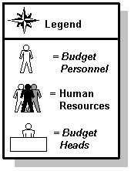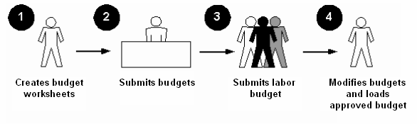

What happens

The stages of the process are described in this table.

|  |  |
| --- | --- |
| **Stage** | **Description** |
| 1 | Budget personnel create budget worksheets. |
| 2 | Budget heads submit budgets. |
| 3 | Human Resources submit labor budgets. |
| 4 | Budget personnel modify the budgets and load the approved budget. |

Set Up



Section goal

The purpose of this section is to outline the set-up process and detail the process to set up your Banner system to handle budget development at your institution.

Objectives

In this section you will learn how to

* build a budget ID and phases
* load a manual budget
* load an electronic budget.

Forms Required to Build System Information



Data entry forms

Data entry forms enable you to build information into the Banner System. The forms below are used to enter information.

|  |  |
| --- | --- |
| **Form Description** | **Banner Name** |
| Operating Budget Maintenance | FTMOBUD |
| Budget Request by Account | FBABDRA |
| Budget Process Control Parameter | FBABPRC |

Building a Budget ID and Phases



Introduction

Users create and maintain budget ID and phases using the Operating Budget Maintenance Form (FTMOBUD). This form is a maintenance form and can be used to make an unlimited number of phases in Banner. If you have entered information previously and need to modify or edit it now, you must enter a query, retrieve the data, and execute the query. If you were to just begin entering data in the form, you would only be in input mode. Because this is the first entry you will make, there is no need to query this time.

Banner form

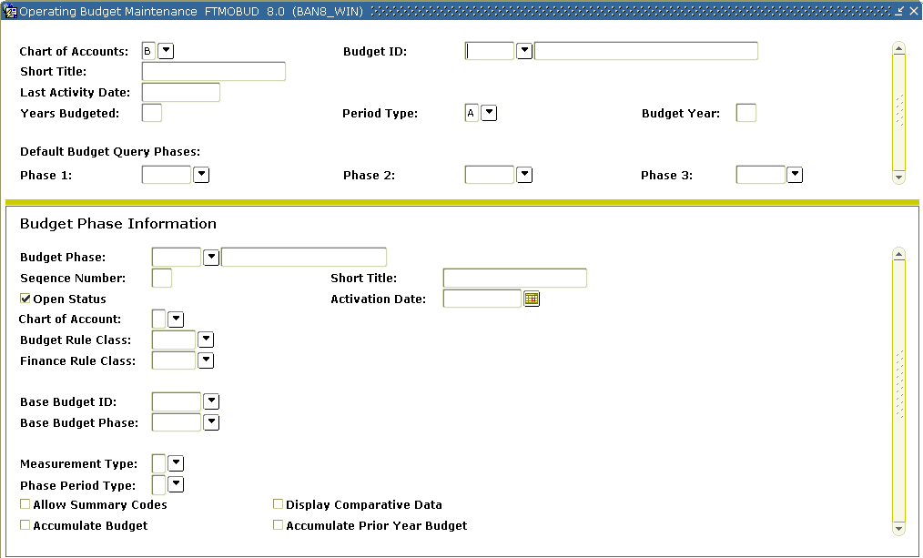

Steps

Follow these steps to complete the process.

1. Access the Operating Budget Maintenance Form (FTMOBUD).
2. Create a unique budget ID of your own.

Notes: Do not duplicate the budget ID used by any other training participants.

It is necessary to establish a Budget ID for each budget. The **Budget ID** field allows for a unique six-character code. Make note of this **Budget ID** exactly as you enter it—you will be using it repeatedly in these exercises.

1. Enter a description for your budget (e.g., *Budget for Fiscal 03-04)*.
2. Enter *B* (or the COA code for your institution) in the **COA** (Chart of Accounts) field.
3. Enter *1* In the **Years Budgeted** field.
4. Enter *A* (Annual) in the **Period Type** field.

Note: Your budget can be distributed for the entire year, (A)nnually, or distributed by (P)eriod within the year. (Budgets are most commonly distributed once for the entire year, i.e., [A]nnually).

1. Enter the corresponding budget year (the fiscal year being budgeted) in the appropriate field.

Note: The fiscal year must be one that you have defined on FTMFSYR.

1. Click the **Save** icon.

Note: This is a prerequisite if additional phases will be created. We will return to this screen to enter the default phases after they have been created in the Budget Phase Data window.

1. Enter *EBASE* in the **Budget Phase** field**.**
2. Enter *Base Phase FY 200?* in the **Title** field.
3. Tab past the **Sequence No** field (to prompt the system to assign a sequence number).
4. Check the **Open Status** box.
5. Leave the **Activation Date** field empty for now.
6. Enter *B* (or the COA code for your institution)in the **COA** (Chart of Accounts) field (use the same code as used in step 5).
7. Enter *BD10* in the **Budget Rule Class** field.
8. Enter *BD01* in the **Finance Rule Class** field.
9. Leave both the **Base Budget ID** and **Base Budget Phase** fields empty.
10. Enter *D* in the **Measurement Type** field.
11. Enter *A* (Annual) in the **Phase Period Type** field (same as first page).

Note: For this lesson, the only checkbox to mark is the **Display Comparative Data** checkbox.

1. Click the **Save** icon.
2. Click the **Exit** icon.

Loading a Budget Manually



Introduction

It is possible to load a budget manually using the Budget Request By Account Form (FBABDRA). Alternatively, it is possible to load a budget phase from some other existing phase or to load it from your operating ledger. In the following exercise, we use the EBASE phase to load a budget manually.

Banner form

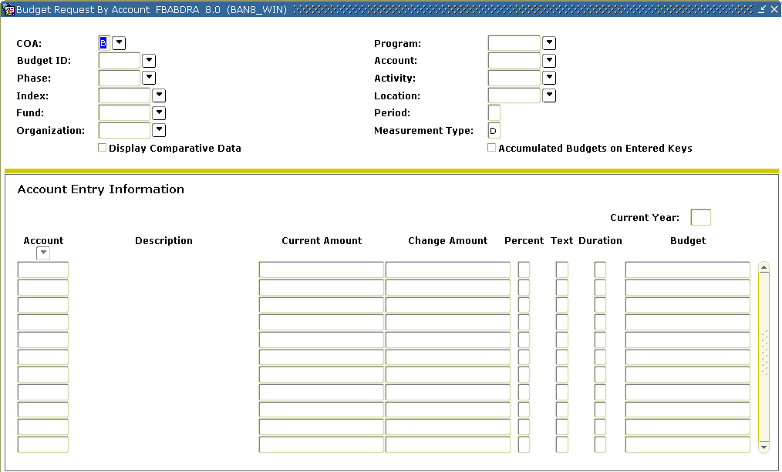

Steps

Follow the steps below to manually load the budget.

1. Access the Budget Request By Account Form (FBABDRA).
2. Enter the budget ID created in the previous exercise in the **Budget ID** field.
3. Enter *EBASE* in the **Phase** field.
4. Enter *B (or the COA code for your institution)* in the **COA** (Chart of Accounts) field.
5. Enter nothing in the **Index** field.
6. Double-click in the **Organization,** **Fund** and **Program** fields, and select valid organization, fund, and program codes.

Notes: Make a note of this information, as you will use it again later on. It would be a good idea for each participant to choose a unique organization code – in order not to interfere with one another’s work.

Do not enter anything in **Account, Activity,** or **Location** fields*.*

1. Navigate to the Account Entry Information block.
2. Enter the information below into the appropriate columns in the block.

Note: The listed account codes will be valid if you are using the test Chart of Accounts B. If you are using your own Chart of Accounts, you must use valid account codes that have been defined for that Chart.

**Organization 1**

**Acct Current Amount**

5210 125000

5220 55500

6121 25500

6122 21000

7110 15000

7210 25000

7310 35000

Note: When entering one or any of the above lines, select **Line Item Text** from the **Options** drop-down menu.

1. **Optional**: Enter narrative associated with this line item.

Note: In the column headed **Dur**, you may designate whether the budgeted amount is (*T*)emporary or (*P*)ermanent.

1. Click the **Save** icon.
2. Perform a **Rollback** function.
3. Repeat steps 1 through 11, selecting a new organization but keeping fund and program the same.
4. Enter the information found in the table below into the appropriate columns in the Account Entry Information block for the new fund. (As in step 8, these account codes will be valid if you are using COA B. Otherwise, you must choose valid codes from your own chart).

**Organization 2**

Acct Current Amount

5210 100000

5220 25000

6121 15500

6122 25000

7110 10000

7210 12000

7310 40000

1. Click the **Save** icon.
2. Click the **Exit** icon.

Loading a Budget Electronically



Introduction

Instead of loading the budget manually each year, you may want to use the previous year’s budget as the starting point or *base* *phase* for the new fiscal year’s budget. This exercise describes how you can load the budget contained in any fiscal year on your operating ledger into a budget phase in your budget module. This budget phase, as will be shown in subsequent exercises, can be used to define further phases. (Often, the initial budget for your first live year on Banner will be loaded electronically from the legacy system using the GURFEED table. The process described here can then be used to upload this information to your budget module as the base for your year 2 budget).

The upload process described here can take quite a long time to run, especially if each participant submits it individually. Plan accordingly, and take turns with the actual submission of the process, step 20.

The steps below moves data from the Banner Operating Ledger into the EBASE phase using the Budge Process Control Parameter Form (FBABPRC).

Banner form

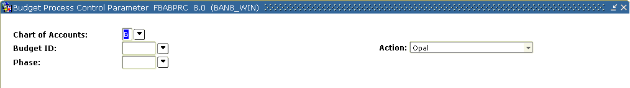

Steps

Follow these steps to complete the form.

1. Access the Budget Process Control Parameter Form (FBABPRC).
2. Enter the previously created ID in the **Budget ID** field.
3. Enter *EBASE* to use the phase we previously created in the **Phase** field.
4. Enter *B* (or the COA code for your institution) in the **COA** (Chart of Accounts) field.
5. Select *Opal* from the drop-down list in the **Action** field.
6. Perform a **Next Block** function to navigate to the Budget Source Data block.

Note: Here you will describe the phase that you wish to copy information from.

1. Enter the chart of accounts from which you wish to upload budget amounts (usually the same as that entered above) in the **Source** **COA** field.
2. Enter the fiscal year from which you wish to upload budget amounts in the **Fiscal Year** field.
3. Enter these fields:

|  |  |
| --- | --- |
| For **Include Original** | select *Y*(es) to include all budgets posted with a BD01 rule code. |
| For **Include Temporary** | select *Y*(es) to include all budget transactions posted with a BD03 or BD04 rule code. |
| Select *Y*(es) **Overwrite** **file** | if you would like the current load to overwrite any existing data for specific fund, organization, account, and program combinations. |
| For **Include Labor** | select *Y*(es) to include all budget transactions posted to account codes that are designated as *L*(abor) expense. |
| For **Include Adjustments** | select *Y*(es) to include all budget transactions posted with a BD02 rule code. |
| For **Build Distributed Budget** | select *N*(o) to bypass building of the FBRDIST table now. |
| For **Insert New** | select *Y*(es) to have the process insert any new combination of Fund, Organization, Account, and Program. |

1. Click the **Save** icon.

Note: Notice the message in the lower left of your screen, advisingyou to run the process **FBRBDBB**. Exit this form to run the process.

Budget Build Process Form (FBRBDBB)

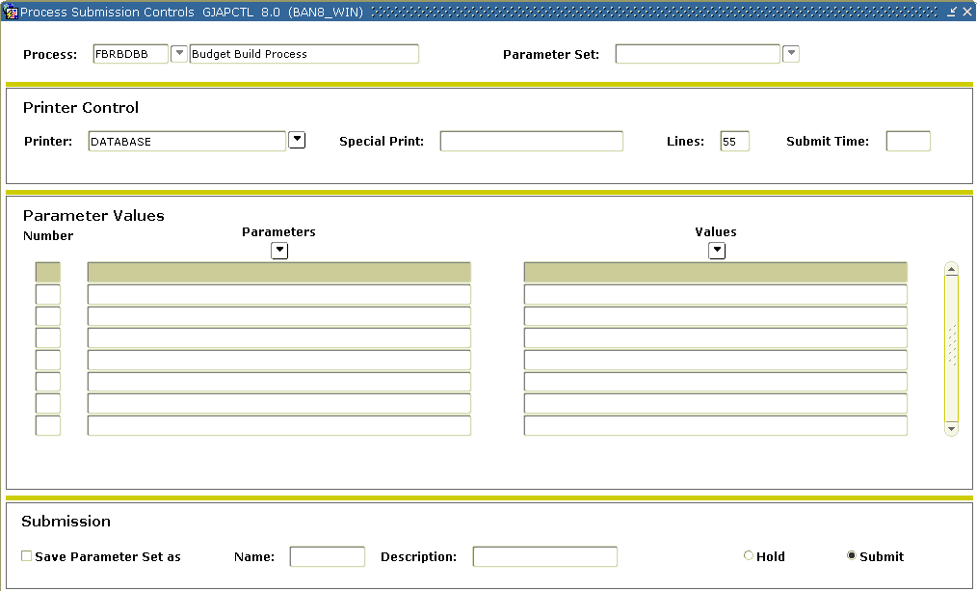

Steps

Follow these steps to complete the form.

1. Access the Budget Build Process Form (FBRBDBB).
2. Select the **Next Block** function.
3. Click the **Submit** radio button to activate the Submission block.
4. Click the **Save** icon to run the process.
5. Use **FBIBUDG** to review your results.

Logging In to Spreadsheet Budgeting



Steps

Follow these steps for logging in to spreadsheet budgeting.

1. Open Microsoft Excel.

Result: The Banner icon should appear.

1. Select **Connect To Database** from the **Banner** pull-down menu.
2. Enter your Oracle ID, password, and the desired database.
3. Click the **Connect** icon.

Notes: Database information will show in the top bar of Excel.

1. The **Switch Connection** option from the **Banner** pull-down menu allows connections to multiple databases.

Loading a Budget Using Spreadsheet Budgeting – Uploading



Downloading from the operating ledger

Follow these steps to download from the operating ledger.

1. Select the **Spreadsheet Budgeting** option from the **Banner** pull down list in Microsoft Excel.
2. Select **Download Wizard** from the **Spreadsheet Budgeting**menu.
3. Click the **Downloading from the Operating Ledger** radio button.
4. Choose the appropriate chart of accounts.
5. Choose the appropriate fiscal year.
6. Click the **Next** button.
7. Choose committed, uncommitted, or both types of encumbrances.
8. Click the **Finish** button to start downloading from the operating ledger.

Note: Specifying FOAPAL elements is optional. If you wish to do this, click **Next** and follow the wizard to define specific FOAPAL elements you wish to download.

Downloading from the grant ledger

Follow these steps to download from the grant ledger.

1. Select the **Spreadsheet Budgeting** option from the **Banner** pull down list in Microsoft Excel.
2. Select **Download Wizard** from the **Spreadsheet Budgeting**menu.
3. Click the **Downloading from the Grant Ledger** radio button.
4. Choose the appropriate chart of accounts.
5. Choose the grant code(s) you want to download.
6. Click the **Next** button.
7. Choose the grant year(s) for the grant code(s) selected above.
8. Click the **Next** button.
9. Choose the grant period to download.

Note: You can choose only one grant period.

1. Choose the type(s) of data to download.

Note: You can select more than one.

1. Click the **Next** button.
2. Click the **Finish** button to start the download from the grant ledger.

Note: Specifying FOAPAL elements is optional. If you wish to do this, click **Next** and follow the wizard to define specific FOAPAL elements you wish to download.

Downloading from budget development

Follow these steps to download from budget development.

1. Select the **Spreadsheet Budgeting** option from the **Banner** pull down list in Microsoft Excel.
2. Select the **Download Wizard** from the **Spreadsheet Budgeting**menu.
3. Select one of the two choices:

* Budget Line Item Table: This looks at the FBBBLIN table for the download.
* Distributed Budget Line Item Table: This looks at the FBRDIST table for the download.

1. Choose the appropriate chart of accounts.
2. Click the **Next** button.
3. Choose the budget ID(s) to download.

Note: You can select more than one. Click the **Next** button.

1. Choose the appropriate phase(s) to download.

Note: You can select more than one. Click the **Next** button.

1. Choose the type(s) of data to download.

Note: You can select more than one. Click the **Next** button.

1. Click the **Finish** button to start the download from budget development.

Note: Specifying FOAPAL elements is optional. If you wish to do this, click **Next** and follow the wizard to define specific FOAPAL elements you wish to download.

Validating Information in Excel



Steps

Follow these steps to validate the spreadsheet data against Banner Finance.

1. Select the **Validation Wizard** from the **Spreadsheet Budgeting** menu.
2. Click the radio button to validate Budget Development.
3. Choose the appropriate worksheet.
4. Select the worksheets that have headers.
5. Select the chart of accounts.
6. Select the Budget ID.
7. Select the Budget Phase.
8. Select whether the data contains Permanent Budget or Permanent and Temporary Budget.
9. Map the columns from the Budget line item table to the appropriate column in the worksheet.
10. Click the **Finish** button.

Self Check



Directions

Use the knowledge you have gained from this training workbook to complete the self check activity below.

Question 1

How many phases can be created in Banner?

Question 2

The set of account codes used to specify a budget is called the  
  
____________________________________________ ledger.

Answer Key for Self Check



Question 1

How many phases can be created in Banner?

**There is no limit to the numbers of phases that can exist in Banner**.

Question 2

The set of account codes used to specify a budget is called the **Operating** ledger.

Day-to-Day Operations



Section goal

The purpose of this section is to explain the day-to-day or operational process to handle budget development.

Objectives

In this section you will learn how to

* inquire on budget information on line
* create budget phases
* roll budgets
* make changes to a budget
* create a labor budget
* run a budget worksheet
* load a budget
* combine budget phases.

Process Introduction



About the process

The Finance Office can

* create budget worksheets
* submit budgets
* modify budgets
* load the approved budget.

Flow diagram

This diagram highlights the processes used in budget development.



What happens

The stages of the process are described in this table.

|  |  |
| --- | --- |
| **Stage** | **Description** |
| 1 | Budget personnel create budget worksheets. |
| 2 | Budget heads submit budgets. |
| 3 | Human Resources submit labor budgets. |
| 4 | Budget personnel modify the budgets and load the approved budget. |

Querying Budget Information Online



Query online

The Budget Query Form (FBIBUDG) has been designed to allow quick online review of up to three budget phases. Phases may be defined as either components of the budget (revenue, labor, capital, etc.) or as steps in the budget process (initial, requested, approved, 10% increase, etc.). FBIBUDG permits you to identify up to three phases that you wish to summarize similarly for comparison or review.

Banner form

The Budget Query Form (FBIBUDG) allows you to view comparative budget phase data. Access this form from the Budget and Position Control System Menu (*FINBUDG).

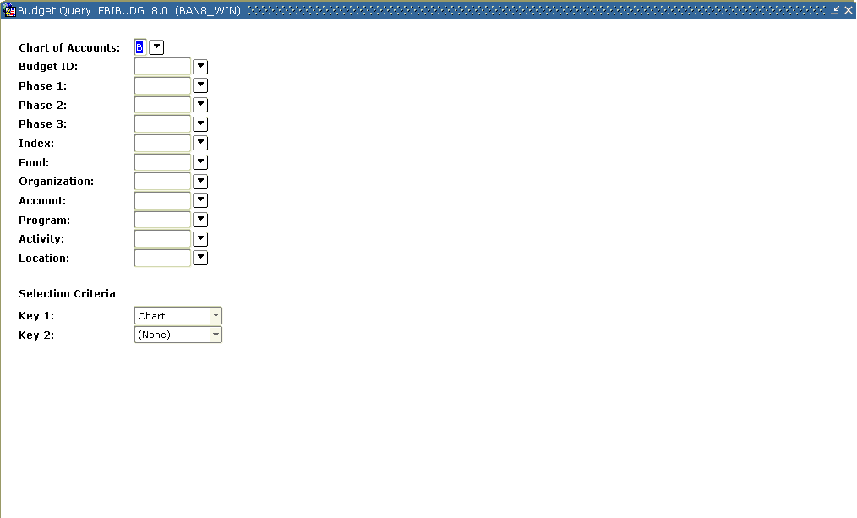

Steps

Follow these steps to perform an online query.

1. Access the Budget Query Form (FBIBUDG).
2. Enter the budget ID created in the first exercise in the **Budget ID** field.
3. Enter *B* (or the COA code for your institution) in the **Chart of Accounts** field.

Notes: Leave all other FOAPAL fields blank. Notice that the three **Phase** fields have default values if they were added on the Budget ID build step on FTMOBUD.

1. Navigate to the **Key 1** field.
2. Select **Organization** from the drop-down list here.
3. Navigate to the **Key 2** field.
4. Select **Account** from the drop-down list.
5. Perform a **Next Block** function and view the data.

Note: The query displays the two organizations for which you entered budget data in Lesson 2.

1. Perform a **Next Block** function.

Note: The program summarizes this budget information.

1. Perform a **Rollback** function and change the **Key 1** option to **Fund**and the **Key 2** option to **Program**.
2. Perform a **Next Block** function and view the data.

Note: Test additional changes in the **Key 1** and **Key 2** fields.

1. Click the **Exit** icon.

Creating Distinct Budget Phases



Introduction

So far we have created base phases, i.e., a phase with your entire budget and all of its component pieces. In many cases you may wish to separate some components of your budget—revenue, capital expense, direct expense, labor, specific funds, organization codes, etc.—**or**, you may wish to deal with distinct phases of your budget process:

* original budget
* requested budget
* approved budget.

In either case, you can use the FTMOBUD form to create these refined *phases*. The Budget Process Control Parameter Form (FBABPRC) makes it possible for you to do copy into these new phases.

In the following example, you will copy the information you loaded in the EBASE phase into the DIREXP phase.

Access the Budget Process Control Parameter Form (FBABPRC) to move data from the EBASE phase into the DIREXP phase. You will then use the Budget Process Control Parameter Form (FBABPRC) to eliminate unwanted accounts from this phase.

Banner form

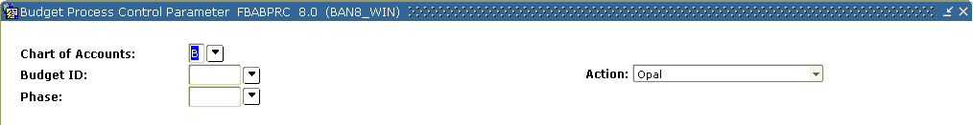

Steps

Follow these steps to complete the process.

1. Access the Budget Process Control Parameter Form (FBABPRC).
2. Enter the previously created ID in the **Budget ID** field.
3. Enter *DIREXP* to use the phase we previously created in the **Phase** field.
4. Enter *B (or the COA code for your institution)* in the **COA** (Chart of Accounts) field.
5. Select *Budget Line* from the drop-down list in the **Action** field.
6. Perform a **Next Block** function to navigate to the Budget Source Data block.

Note: Here you will describe the phase that you wish to copy information from.

1. Select the budget containing the phase from which you want to get information in the **Base Budget ID** field.
2. Select *EBASE* In the **Base Budget** **Phase** field.
3. Enter *B* (or the COA for your institution) in the **Base COA** field.
4. Tab down to the **Additional Parameters** block.

Note: Notice that there is no option for inclusion/exclusion of expense-type accounts. You can select *N*(o) for the Include Labor prompt in order to eliminate those accounts from this phase. Otherwise, respond to these prompts as above.

1. Click the **Save** icon.

Note: The message in the lower left-hand corner of your screen, telling you to run the **FBRBDBB** process.

1. Click the **Exit** icon.
2. Access the Process Submission Control Form (GJAPCTL).
3. Enter *FBRBDBB* in the **Process** field.

Note: This is the Budget Build Process Form.

1. Tab to the Submission block and make sure the **Submit** radio button is selected.
2. Click the **Save** icon to run this process.
3. Access the Budget Query Form (FBIBUDG) to query the results.

Note: The phase displays accounts that are not labor-type accounts.

1. Return to FBABPRC.
2. Enter your Budget ID in the **Budget ID** field.
3. Enter DIREXP to use the phase we just created in the **Phase** field.
4. Enter B (or the COA code for your institution) in the **COA** (Chart of Accounts) field.
5. Select **Delete** from the drop-down list in the **Action** field.

Note: You have the option of deleting by fund type or by account type. In this case, account type is what we want, because we wish to eliminate all accounts that are not direct expense.

1. Enter an *A* for (A)ccount type in the **Type Indicator** column.
2. Tab to the **Type Code** column.

Notes: You can enter a Level 1 or Level II account type code that is not an expense-type account (i.e., that IS revenue or labor). You can query your account type options by using F9 or double-clicking your mouse on this field.

1. Tab down to the next line.
2. Enter **Type Indicator** of A.
3. Tab to the **Type Code** field and list the next non-expense account type code.

Note: Repeat until all non-expense account types (all of the account types that you want excluded from this phase) have been listed.

1. Click the **Save** icon.

Note: The message in the lower left-hand of your screen tells you to run the **FBRBDBB** process.

1. Click the **Exit** icon.
2. Access the Process Submission Control Form (GJAPCTL).
3. Enter FBRBDBB in the **Process** field.

Note: This is the Budget Build Process Form.

1. Tab to the Submission block and activate the **Submit** radio button.
2. Click the **Save** icon to run this process.
3. Access the Budget Query Form (FBIBUDG) to query the results.

Rolling Data from Phase to Phase



New fiscal year budget phase

In the previous exercise, we created a phase with only direct expense type accounts DIREXP. Though this phase differs from EBASE in that it only includes direct expense account codes, the budget values are still identical to those with which we started. Using DIREXP, we now want to create a budget phase for budget holders to use in requesting budget changes for the new fiscal year. We will create a new phase, DEPTRQ, as a simple copy of DIREXP. First, you will have to create this phase in the Operating Budget Maintenance Form (FTMOBUD) then you will have to populate it using the Budget Process Parameter Form (FBABPRC).

In the following steps, you will first define a new phase, DEPTRQ (using FTMOBUD). Then you will move data from the DIREXP phase into the DEPTRQ phase using the Budget Process Control Parameter Form (FBABPRC).

Banner form

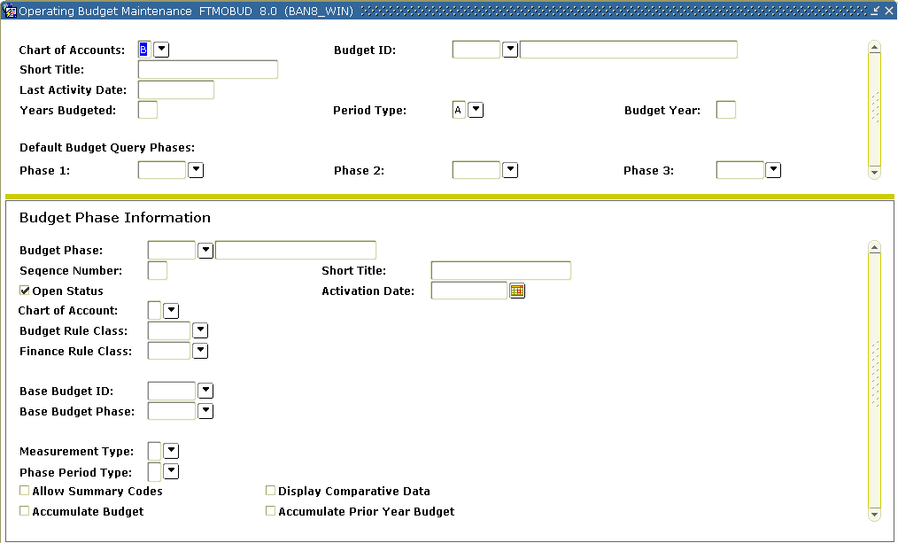

Steps

Follow these steps to complete the process.

1. Access the Operating Budget Maintenance Form (FTMOBUD).

Note: To review information that has already been created you must first enter a QUERY.

1. Perform an **Enter** query.
2. Enter the **Budget ID** you already created.

Note: Execute the query (F8 or select from the toolbar). All the fields you previously entered should display.

1. Create a new phase record with an **Insert Record** function (F6 or select from the toolbar).
2. Enter *DEPTRQ* in the **Budget Phase** field.
3. Enter Department Requested in the **Title** field.
4. Tab past the **Sequence No** field (to prompt the system to assign a sequence number).
5. Check the **Open Status** check box.
6. Leave the **Activation Date** field empty for now.
7. Enter B(or the COA code for your institution) in the **COA** (Chart of accounts) field*.*
8. Enter *BD10* in the **Budget Rule Class** field.
9. Enter *BD01* in the **Finance Rule Class** field.
10. Enter your Budget ID in the **Base Budget ID** field.
11. Enter *DIREXP* in the **Base Budget Phase** field.
12. Enter *D* in the **Measurement Type** field.
13. Enter *A* (Annual) in the **Phase Period Type** field (same as first page).
14. Click the **Save** icon.

Budget Process Control Parameter Form (FBABPRC)

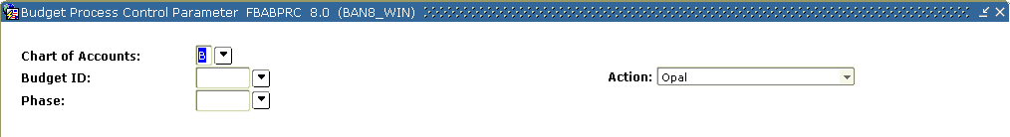

Steps

Follow these steps to complete the process.

1. Access the Budget Process Control Parameter Form (FBABPRC).
2. Enter the previously created ID in the **Budget ID** field.
3. Enter DEPTRQ in the **Phase** field.
4. Enter B (or the COA code for your institution) in the **COA** (Chart of Accounts) field.
5. Select *Budget Line* in the **Action** field.
6. Perform a **Next Block** function to navigate to the Budget Source Data block.

Note: Here you will describe the phase that you wish to copy information from.

1. Enter your Budget ID in the **Base Budget ID** field.
2. Enter DIREXP in the **Base Budget Phase** field.
3. Enter B (or the COA for your institution) in the **Base COA** field.
4. Tab down to the Additional Parameters block.

Steps, continued

1. Enter these values:

|  |  |
| --- | --- |
| For **Include** **Original** | select Y(es) to include all budgets posted with a BD01 rule code. |
| For **Include** **Temporary** | select Y(es) to include all budget transactions posted with a BD03 or BD04 rule code. |
| Select Y(es) to overwrite the file | if you would like the current load to overwrite any existing data for specific fund, organization, account and program combinations. |
| For **Include Labor** | select N(o*)* since there are no budget transactions posted to account codes that are designated as (L)abor expense in the DIREXP Phase. |
| For **Include Adjustments** | select Y(es) to include all budget transactions posted with a BD02 rule code. |
| For **Build Distributed Budget** | select N(o) to bypass building of the FBRDIST table now. |

1. Click the **Save** icon.

Note: The message in the lower left of your screen advises you to run the process FBRBDBB. Exit this form to run the process.

Budget Build Process Form (FBRBDBB)



Steps

Follow these steps to complete the process.

1. Access the Budget Build Process Form (FBRBDBB).
2. Tab to the Submission block and activate the **Submit** radio button.
3. Click the **Save** icon in the toolbar to run this process.
4. Access the Budget Query Form (FBIBUDG) to query the results.

Note: The default values in the three **Phase** fields do not display the phases we have just created. Ensure that the DIREXP and DEPTRQ phases are identical.

Changing Line Items Within a Budget



Introduction

Now that you have created a phase for recording departmental budget requests, you are ready to adjust it with those requests. You can use the Budget Request By Account Form (FBABDRA) to modify or add individual budget line items in an existing budget phase.

Follow the steps below using FBABDRA to update individual amounts in your DEPTRQ budget phase.

Banner form



Steps

Follow these steps to complete the process.

1. Access the Budget Request by Account Form (FBABDRA).
2. Enter the budget ID created for earlier exercises In the **Budget ID** field.
3. Enter *DEPTRQ* in the **Phase** field.
4. Enter *B* (or your institutions COA code) in the **COA** field.
5. Select the organization that was used in previous exercises in the **Organization** field.
6. Select one of the funds used previously in the **Fund** field.
7. Select the program code that was used previously in the **Program** field.
8. Choose one of the accounts entered in previous exercises in the **Account** field.
9. Enter *5* in the **Change Amount** field.

Note: This value represents a 5 percent increase in the total that is indicated in the **Current Amount** field.

1. Enter a *P* (for percent) in the **%** field.
2. Click the **Save** icon.

Note: You should see the change to your entry immediately reflected in the **Current Amount** field.

1. Perform an **Insert Record** function.
2. Enter a valid account code (an expense account) in the **Account** field.
3. Enter a dollar amount for this new account code in the **Current Amount** field.

Note: Do not enter anything in the **%** field.

1. Use FBIBUDG to review your changes.

Making Mass Changes within a Phase



Introduction

It is possible to use Banner’s budgeting functionality to make broad, across the board changes to all or some components of a budget phase. You may, for instance, want to create a phase that records an across-the-board percentage increase for comparison with requested budget amounts. It is possible to make such changes to increase or decrease the budgets in a phase using the Mass Budget Change Form (FBAMCHG).

In this exercise, you will create a new phase, PLUS8 in the Operating Budget Maintenance Form (FTMOBUD). You will use the Budget Process Control Parameter Form (FBABPRC) to populate this phase, and the Budget Mass Change Form (FBAMCHG) to apply an 8% increase.

Banner form



Steps

Follow these steps to complete the process.

1. Access the Operating Budget Maintenance Form (FTMOBUD).

Reminder: This is a maintenance form. To review information that has already been created (in Lesson 1) you must first enter a Query. Perform an enter query (F7 or select from the toolbar). Then enter the **Budget ID** you created previously. Execute the query (F8 or select from the toolbar).

1. Create a new phase record with an insert record function (F6 or use the toolbar).
2. Enter *PLUS8* in the **Budget Phase** field.
3. Enter *8 Percent Increase* in the **Title** field.
4. Tab past the **Sequence No** field (to prompt the system to assign a sequence number).
5. Check the **Open Status** check box.
6. Leave the **Activation Date** field empty for now.
7. Enter *B* (or the COA code for your institution) in the **COA** (Chart of Accounts) field.
8. Enter *BD10* in the **Budget Rule Class** field.
9. Enter *BD01* in the **Finance Rule Class** field.
10. Enter your budget ID in the **Base Budget ID** field.
11. Enter *DIREXP* in the **Base Budget Phase** field.
12. Enter *D* in the **Measurement Type** field.
13. Enter *A* (Annual) in the **Phase Period Type** field (same as first page).
14. For this lesson, the only check box to mark is the **Display Comparative Data** box.
15. Click the **Save** icon.

Budget Process Control Parameter (FBABPRC)

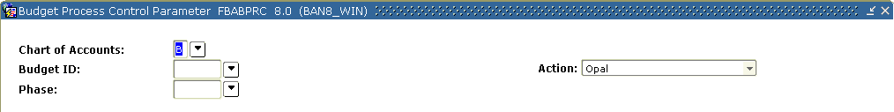

Steps

Follow these steps to complete the process.

1. Access the Budget Process Control Parameter Form (FBABPRC).
2. Enter your budget ID in the **Budget ID** field.
3. Enter *PLUS8* In the **Phase** field.
4. Enter B (or the COA code for your institution) in the **COA** (Chart of Accounts) field.
5. Select *Budget Line* from the drop-down list in the **Action** field.
6. Perform a **Next Block** function to navigate to the Budget Source Data block.

Note: Here you’ll describe the phase you want to copy info from.

1. Enter your budget ID in the **Base** **Budget** **ID** field.
2. Enter *DIREXP* in the **Base** **Budget** **Phase** field.
3. Enter *B* (or the COA for your institution) in the **Base** **COA** field.
4. Tab down to the Additional Parameters block.

Note: You may leave the parameters as they default.

1. Click the **Save** icon.

Note: The message in the lower left of your screen, advising you to run the process FBRBDBB.

1. Click the **Exit** icon.

Budget Build Process Form (FBRBDBB)



Steps

Follow these steps to complete the process.

1. Access the Budget Build Process Form (FBRBDBB).
2. Navigate to the Submission block.
3. Make sure the **Submit** radio button is selected.
4. Click the **Save** icon to run this process.

Budget Query form (FBIBUDG)



Steps

Follow these steps to complete the process.

1. Access the Budget Query Form (FBIBUDG) to query the results.

Note: The default values in the three **Phase** fields do not display the phases we have just created. Ensure that the DIREXP and PLUS8 phases are identical.

1. Access the Mass Budget Change Form (FBAMCHG).
2. Enter your budget ID In the **Budget ID** field.
3. Enter *PLUS8* in the **Budget Phase** field.
4. Enter *B* In the **COA** field.
5. Double-click in the **Organization** field and select an organization to change.
6. Double-click in the **Fund** field and select a fund within the organization to change.
7. Enter an *8* (to represent an 8% budget increase) in the **Change Percent** field.
8. Select the **Change all the budgets within** check box to increase all budgets within the fund you selected by eight percent.
9. Click the **Save** icon.

Note: The message at the lower left of your screen advises you to run the FBRMCHG process.

1. Access the Process Submission Control Form (GJAPCTL).
2. Enter FBRMCHG in the **Process** field.

Note: This is the Budget Build Process Form.

1. Navigate to the Submission block and make sure the **Submit** radio button is selected.

Note: The FBRMCHG process will apply ALL of the records created in FBAMCHG, so only one submission of this process is necessary. If it is submitted twice, the changes may be applied twice.

1. Click the **Save** icon in the toolbar to run this process.
2. Query the results on the Budget Query Form (FBIBUDG).

Note: The records you created in FBAMCHG are not automatically deleted. Unless you delete them from the form now, they will still exist and may be reapplied the next time you or anyone else submits the FBRMCHG process.

Mass Budget Change Form (FBAMCHG)

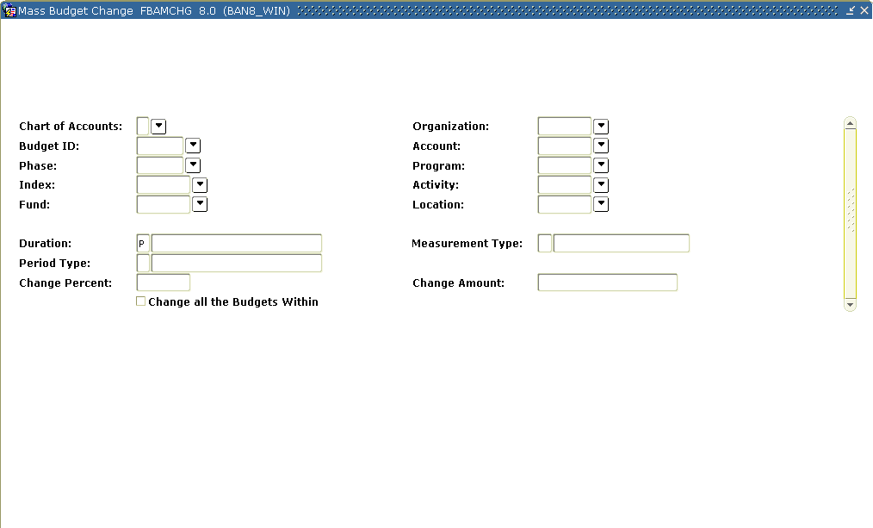

Steps

Follow these steps to complete the process.

1. Access the Mass Budget Change Form (FBAMCHG).
2. Enter a query and retrieve your Budget ID and Phase.
3. Delete your entry.

Creating a Working Labor Budget



Budget roll process

You have the option to load budget figures for your labor accounts directly from your Position Control records in the Banner Human Resources module. Budget figures for each position and the FOAPAL elements to which they are assigned can be found in the Position Budget Form (NBAPBUD). All Position Control budgets must have a valid Budget ID and phase, defined in FTMOBUD. Position Control Budgets are created manually, either through the Position Budget Form (NBAPBUD), or through the Budget Roll Process (NBPBROL).

You can apply mass increases/decreases to a labor budget if you enter mass change parameters in the NTRBROL form before you submit the NBPBROL process.

Use the Budget Roll Process (NBPBROL) to create a working budget. You will use the budget ID and the phase LBASE that you defined in Creating the Budget ID and phases. You will then use the Position Budget Form (NBAPBUD) to review your new budget.

Banner form

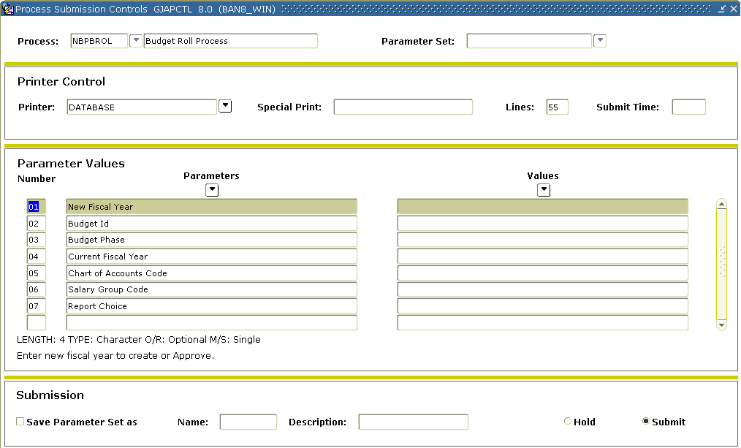

Steps

Follow these steps to complete the process.

1. Access the Process Submission Control Form (GJAPCTL).
2. Enter NBPBROLin the **Process** field.
3. Perform a **Next Block** function and enter either a destination printer or DATABASE.
4. Perform **Next Block** function and tab to the **Values** column.
5. Enter the four-digit fiscal year of the budget you are creating in the **Fiscal Year** field.
6. Enter the budget ID created for earlier exercises in the **Budget ID** field.
7. Enter LBASE in the **Phase** field.
8. Enter the year in the **Current FY** field.

Note: 2001 must be designated as the current fiscal year in the NBAFISC form or this process will return an error.

1. Enter the Chart of Account code in the **Chart of Account** (COA) field.
2. Enter the salary group in the **Salary Group** field.
3. Enter *R* in the **Report Type** field.

Note: The other options for **Report** **Type** are *A* to approve the budget and *D* to delete the budget. You can only delete a budget with a status of working. Once the budget is approved, it will update both the budget module and the operating ledger.

1. Perform **Next Block** function.
2. Click the **Save** icon.
3. Review your output.

Position Budget (NBAPBUD)

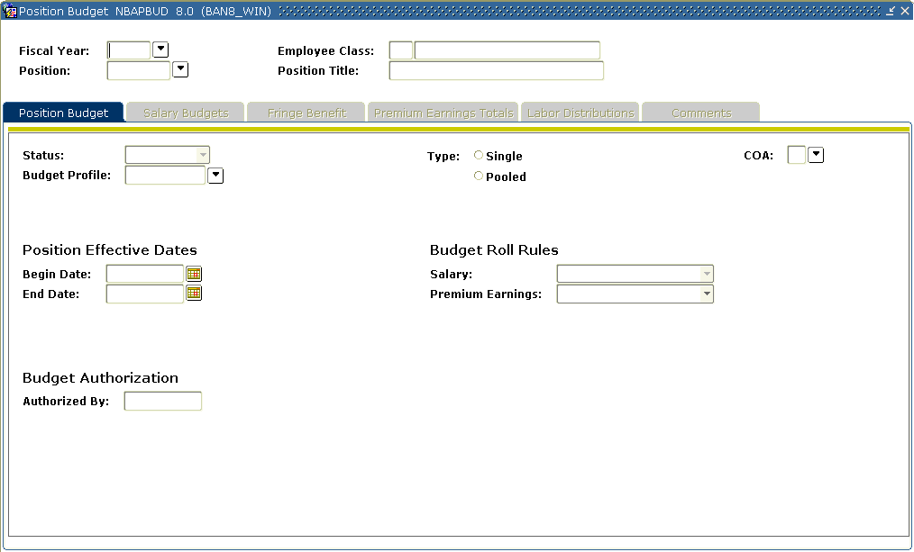

Steps

Follow these steps to complete the process.

1. Access the Position Budget Form (NBAPBUD).
2. Enter the fiscal year you used for step 5 in the previous exercise in the **Fiscal Year** field.
3. Select a valid position from the listed values in the **Position** field.
4. Perform a **Next Block** function.

Salary Budgets tab

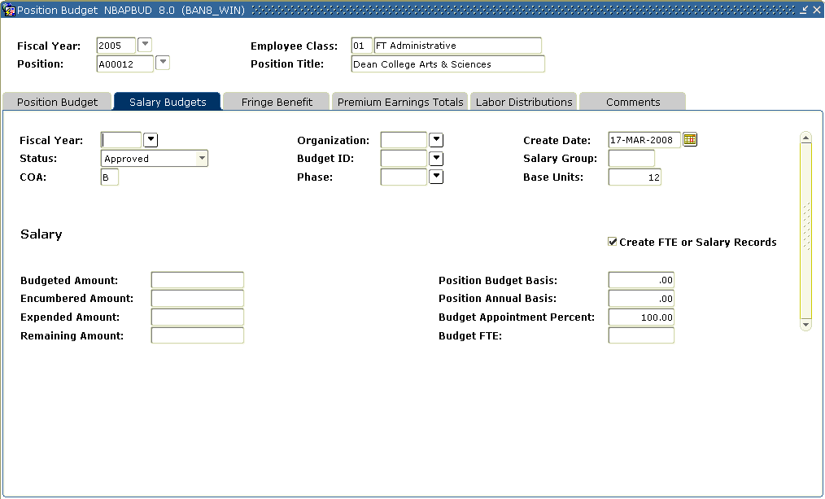

Steps

Follow these steps to complete the process.

1. Select the **Salary Budgets** tab.
2. Verify that your Budget Id and Phase are displayed.

Fringe Benefit tab

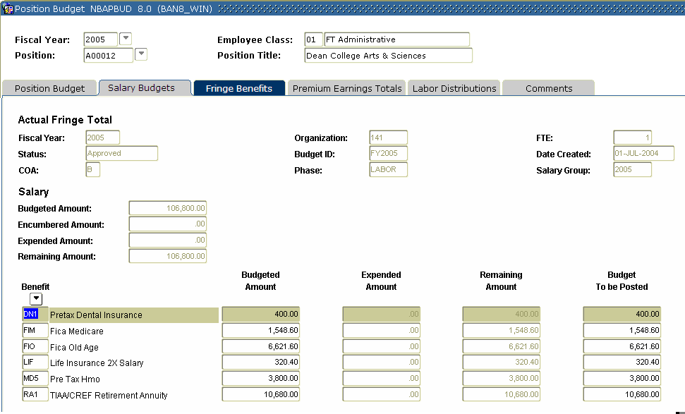

Steps

Follow these steps to complete the process.

1. Select the **Fringe Benefit** tab.
2. Verify that your information is correct.

Premium Earnings tab

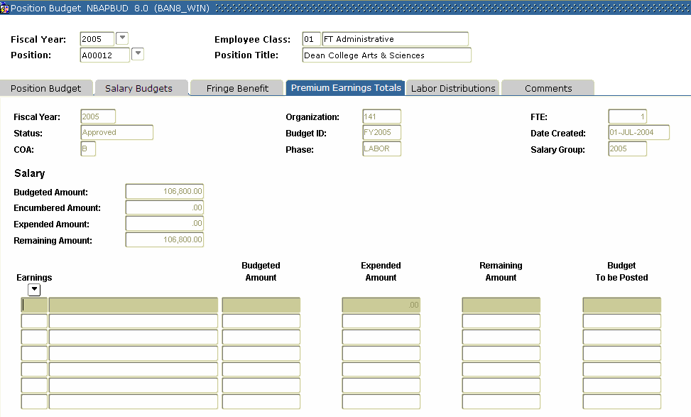

Steps

Follow these steps to complete the process.

1. Select the Premium Earnings Totals tab.
2. Verify that your information is correct.

Labor Distributions tab

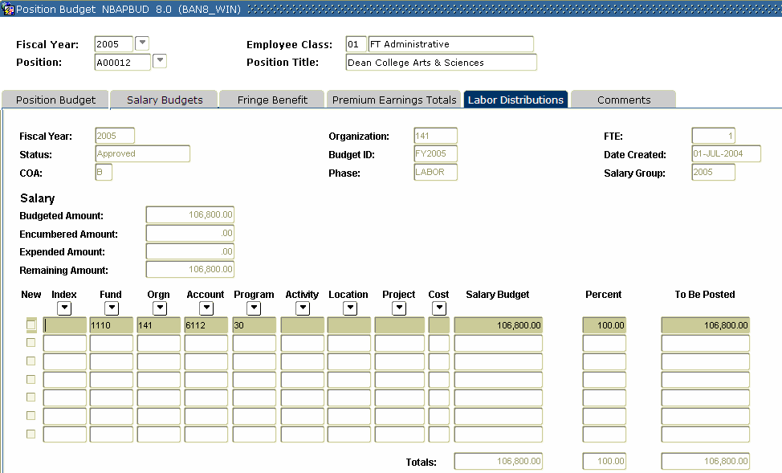

Steps

Follow these steps to complete the process.

1. Select the **Labor Distributions** tab.
2. Review the FOAPAL elements specified.
3. Perform a **Rollback** function and review the budget figures for other position codes.

Running a Labor Budget Worksheet



Position Control Budget Worksheet

The Position Control Budget Worksheet (NBRBWRK) can be generated for any budget that has been created in NBAPBUD, either directly or through the Budget Roll process (NBPBROL), as discussed in the preceding exercise. The Budget Worksheet provides a form for review and revision of the labor budget before it is interfaced to the budget module.

Banner form

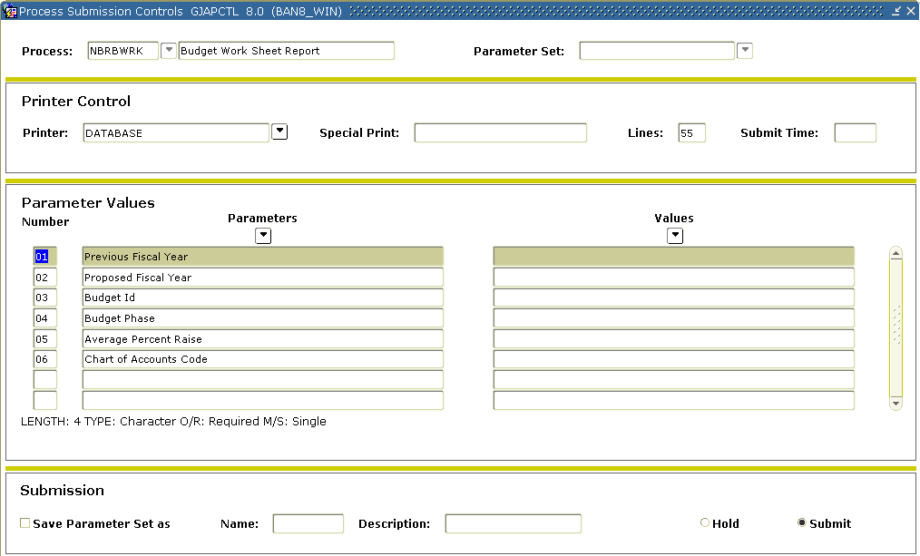

Steps

Follow these steps to complete the process.

1. Access the Position Control Budget Worksheet (NBRBWRK).
2. Enter either a destination printer or DATABASE in the **Printer** field.
3. Enter these parameter values.

|  |  |
| --- | --- |
| **Parameter** | **Description** |
| 01: Previous Fiscal Year | Enter 2001. |
| 02: Proposed Fiscal Year | Enter the applicable term codes to be listed on the report. (This is a repeating parameter so the parameter would be listed once for each of the desired terms to be reported). |
| 03: Budget ID | Enter your budget ID, as used in preceding lessons. |
| 04: Budget Phase | Enter the LBASE phase you defined in Creating the Budget ID and Phases. |
| 05: Average Percentage Increase | Enter 0. |
| 06: Chart of Accounts | Enter B. |

1. Click the **Save Parameter Set as** checkbox.
2. Enter a name and description in the **Name** and **Description** fields.
3. Click the **Submit** radio button.

Note: The Budget Worksheet is a large listing. If you are in a group, only one person needs to submit and print a copy.

1. Click the **Save** icon to execute the report.
2. Select **Review Output** on the **Options** menu to review the report.
3. Click the **Exit** icon.

Loading a Labor Budget to Finance



Banner forms

Once you have loaded the budget, either manually through NBAPBUD or by running the NBPBROL process, then you can interface this budget to the finance budget module. This is done in three steps. The process NHPFIN1 loads the budget records into the NHRFINC table. The process NHPFIN2 puts these records into the Finance portal table, GURFEED. Finally, the FBRFEED process will pick up the records from GURFEED and load them into the FBBBLIN table, where they can be reviewed using the FBIBUDG form.

In the following steps, you will interface your working budget to the budget module using three processes: NHPFIN1, NHPFIN2, and FBRFEED. You will then review your labor phase in FBIBUDG.

Finance Extract Process (NHPFIN1)

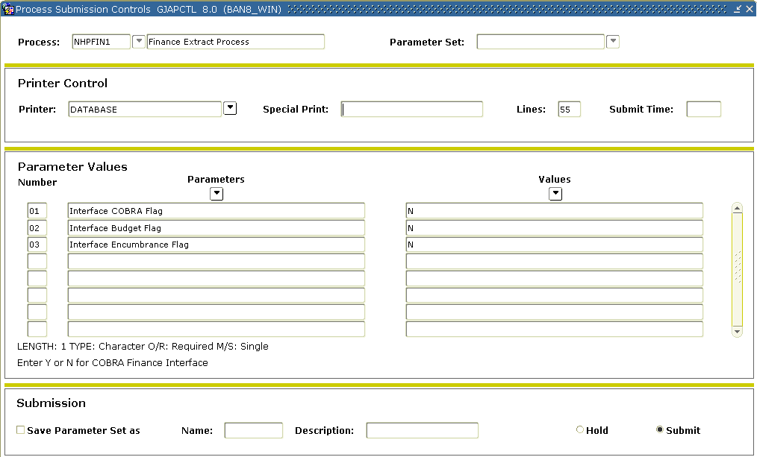

Steps

Follow these steps to complete the process.

1. Access the Finance Extract Process (NHPFIN1).
2. Enter either a destination printer or DATABASE in the **Printer** field.
3. Enter these parameter values.

|  |  |
| --- | --- |
| **Parameter** | **Description** |
| 01: Interface COBRA | Enter N. |
| 02: Interface Budget | Enter Y. |
| 03: Interface Encumbrance | Enter N. |

1. Click the **Save Parameter Set as** checkbox.
2. Enter a name and description in the **Name** and **Description** fields.
3. Click the **Submit** radio button.
4. Click the **Save** icon to execute the report.
5. Select **Review Output** on the **Options** menu to review the report.
6. Click the **Exit** icon.

Finance Interface Report (NHPFIN2)

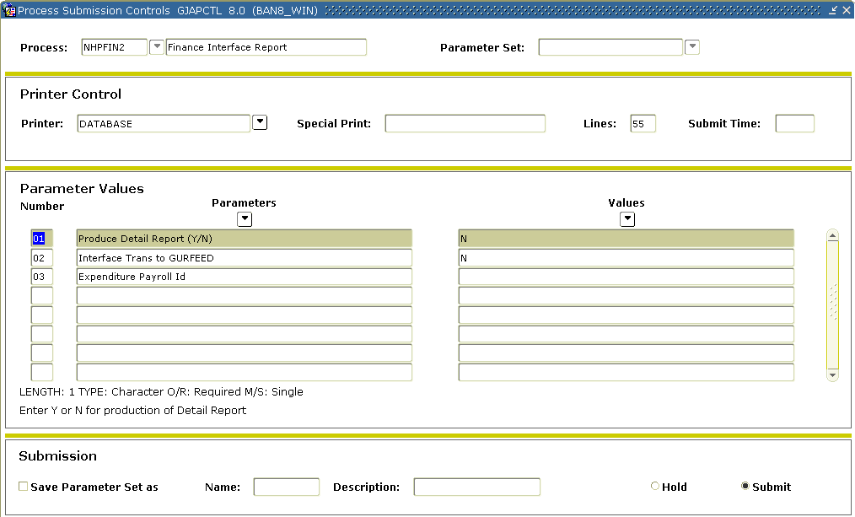

Steps

Follow these steps to complete the process.

1. Access the Finance Interface Report (NHPFIN2).
2. Enter either a destination printer or DATABASE in the **Printer** field.
3. Enter these parameter values.

|  |  |
| --- | --- |
| **Parameter** | **Description** |
| 01: Produce Detail Report (Y/N) | Enter Y. |
| 02: Interface Trans to GURFEED | Enter Y. |
| 03: Expenditure Payroll ID | Leave blank. |

1. Click the **Save Parameter Set as** checkbox.
2. Enter a name and description in the **Name** and **Description** fields.
3. Click the **Submit** radio button.
4. Click the **Save** icon to execute the report.
5. Select **Review Output** on the **Options** menu to review the report.
6. Click the **Exit** icon.

Finance Budget Feed Process (FBRFEED)

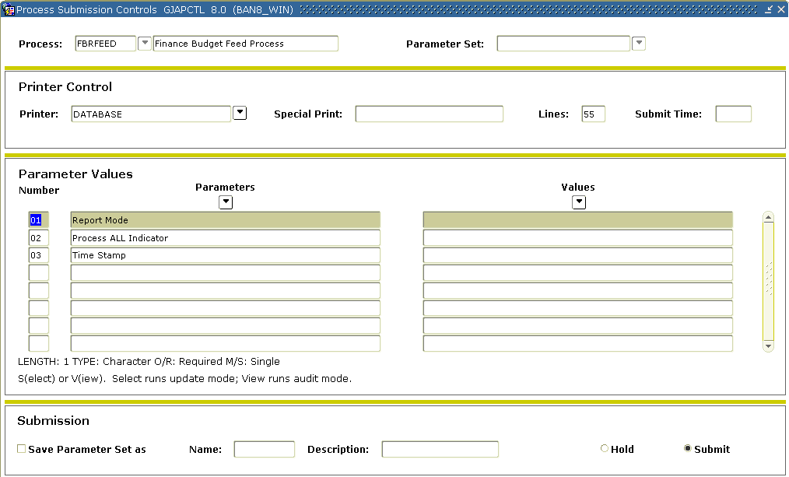

Steps

Follow these steps to complete the process.

1. Access the Finance Budget Feed Process (FBRFEED).

Note: FBRFEED picks up the records in the GURFEED table with a System ID = POSNBUD.

1. Enter either a destination printer or DATABASE in the **Printer** field.
2. Enter these parameter values.

|  |  |
| --- | --- |
| **Parameter** | **Description** |
| 01: Report Mode | Enter S. |
| 02: Process ALL Indicator | Enter Y. |
| 03: Time Stamp | Leave blank. |

1. Click the **Save Parameter Set as** checkbox.
2. Enter a name and description in the **Name** and **Description** fields.
3. Click the **Submit** radio button.
4. Click the **Save** icon to execute the report.
5. Select **Review Output** on the **Options** menu to review the report.
6. Click the **Exit** icon.

Budget Query (FBIBUDG)



Steps

Follow these steps to complete the process.

1. Access the Budget Query Form (FBIBUDG) and review the values in the LBASE phase of your budget.

Combining Budget Phases



Introduction

The Budget Process Control Form (FBABPRC) can be used to recombine separate phases into one large phase. This can be useful, for example, in consolidating a final approved version of your budget. In this exercise, you create an approved phase that combines some of the specialized phases you have created in preceding lessons.

Operating Budget Maintenance Form (FTMOBUD)



Steps

Follow these steps to complete the process.

1. Access the Operating Budget Maintenance Form (FTMOBUD).

Reminder: This is a maintenance form. To review information that has already been created you must first enter a query. Perform a **Query** function. Then enter the **Budget ID** you created previously. Execute the query (F8 or select from the toolbar). All the fields you entered in Lesson 1 should display.

1. Perform a **Next Block** function.
2. Create a new phase record by performing an **Insert Record** function.
3. Enter APPRVD in the **Budget Phase** field.
4. Enter Approved Budget in the **Title** field.
5. Tab past the **Sequence No** field (to prompt the system to assign a sequence number).
6. Check the **Open Status** check box.
7. Leave the **Activation Date** field empty for now.
8. Enter B (or the COA code for your institution) in the **COA** (Chart of Accounts) field*.*
9. Enter BD10 in the **Budget Rule Class** field.
10. Type BD01 in the **Finance Rule Class** field.
11. Enter your budget ID in the **Base Budget ID** field.
12. Leave the **Base Budget Phase** field blank.
13. Enter D in the **Measurement Type** field.
14. Enter A(nnual) in the **Phase Period Type** field (same as first page).

Note: For this lesson, the only check box to mark is the **Display Comparative Data** check box.

1. Click the **Save** icon.

Budget Process Control Parameter Form (FBABPRC)

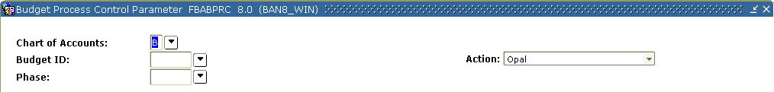

Steps

Follow these steps to complete the process.

1. Access the Budget Process Control Parameter Form (FBABPRC).
2. Enter the previously created ID in the **Budget ID** field.
3. Enter APPRVD in the **Phase** field.
4. Enter B (or the COA code for your institution) in the **COA** (Chart of Accounts) field.
5. Select **Budget Line** from the drop-down list in the **Action** field.
6. Perform a **Next Block** function to navigate to the Budget Source Data block.

Note: Here you will describe the phase that you wish to copy information from.

1. Enter your budget ID in the **Base Budget ID** field.
2. Enter DIREXP in the **Base Budget Phase** field.
3. Enter B (or the COA for your institution) in the **Base COA** field.
4. Tab down to the Additional Parameters block.
5. Select *Y*(es) to include all budgets posted with a BD01 rule code in the **Include** **Original** field.
6. Select *Y*(es) to include all budget transactions posted with a BD03 or BD04 rule code in the **Include** **Temporary** field.
7. Select *Y*(es) to overwrite the file, if you would like the current load to overwrite any existing data for specific fund, organization, account, and program combinations.
8. Select *N*(o) in the **Include Labor** field since there are no budget transactions posted to account codes that are designated as (L)abor expense in the DIREXP Phase.
9. Select *Y*(es) to include all budget transactions posted with a BD02 rule code in the **Include** **Adjustments** field.
10. Select *N*(o) in the **Build** **Distributed** **Budget** field to bypass building of the FBRDIST table now.
11. Click the **Save** icon.

Note: Notice the message in the lower left of your screen advising you to run the process FBRBDBB.

1. Click the **Exit** icon.

Budget Build Process Form (FBRBDBB)



Steps

Follow these steps to complete the process.

1. Access the Budget Build Process Form (FBRBDBB).
2. Navigate to the Submission block and make sure the **Submit** radio button is selected.
3. Click the **Save** icon to run this process.

Budget Query Form (FBIBUDG)



Steps

Access the query forms to review the data. Follow these steps to complete the process.

1. Access the Budget Query Form (FBIBUDG) to query the results.

Note: Ensure that, at this point, the APPRVD phase matches the DIREXP phase.

1. Access the Budget Process Control Form (FBABPRC).

Note: To add the budget from your LBASE phase to this same APPRVD phase, repeat the steps above.

1. Access the Budget Query Form (FBIBUDG) and verify that the APPRVD phase is now a combination of LBASE and DIREXP.

Rolling Approved Budget Phase to the Operating Ledger



Fiscal year maintenance

After your department’s budget has been finally approved, you will want to roll it over to the operating ledger in preparation for the upcoming fiscal year. This process posts and activates the budget for the new fiscal year.

Banner form

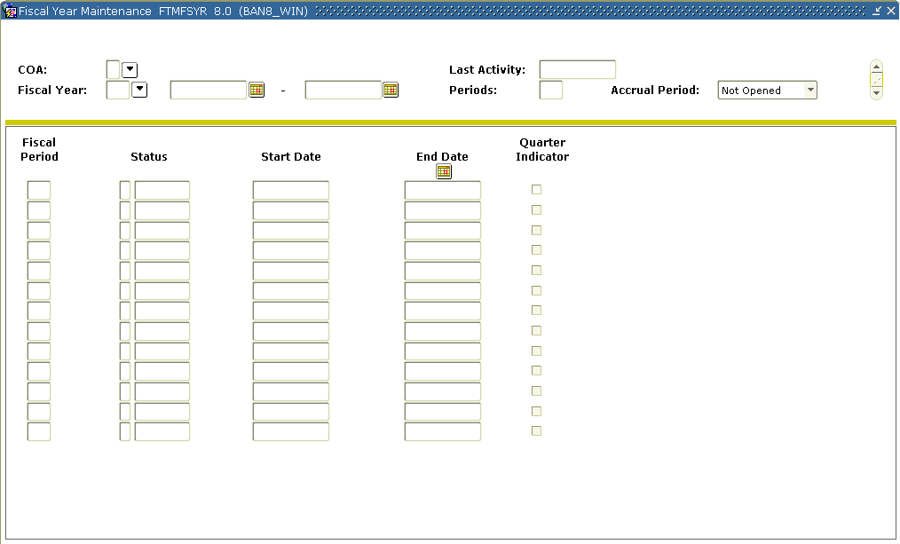

Steps

Follow these steps to roll over an approved budget for the upcoming fiscal year.

1. Access the Fiscal Year Maintenance Form (FTMFSYR).
2. Verify that the new fiscal year for which you want to roll the budget is defined and open, and at least, the fiscal period 01 is open.

System Data Maintenance (FTMSDAT)

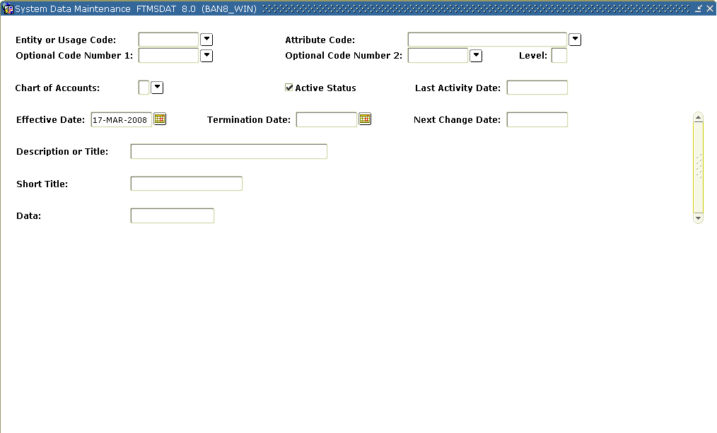

Steps

Follow these steps to complete the process.

1. Access the System Data Maintenance Form (FTMSDAT) and put the form in query mode.
2. Click in the **Optional Code Number 1** field.
3. Enter the search parameter *Budget*in this field in Query mode. Now execute the query.

Note: It is necessary that this code exist before rolling to the ledger.

Operating Budget Maintenance (FTMOBUD)



Steps

Follow these steps to complete the process.

1. Access the Operating Budget Maintenance Form (FTMOBUD).
2. Perform a **Next Block** function to move to the Budget Phase Information window.
3. Uncheck the **Open Status** field to close these phases in each of the phases other than APPRVD.
4. Open the APPRVD phase.
5. Specify a date to activate this phase in the **Activation Date** field (usually the first day of the new fiscal year).

Budget Distribution Parameter form (FBABDDS)

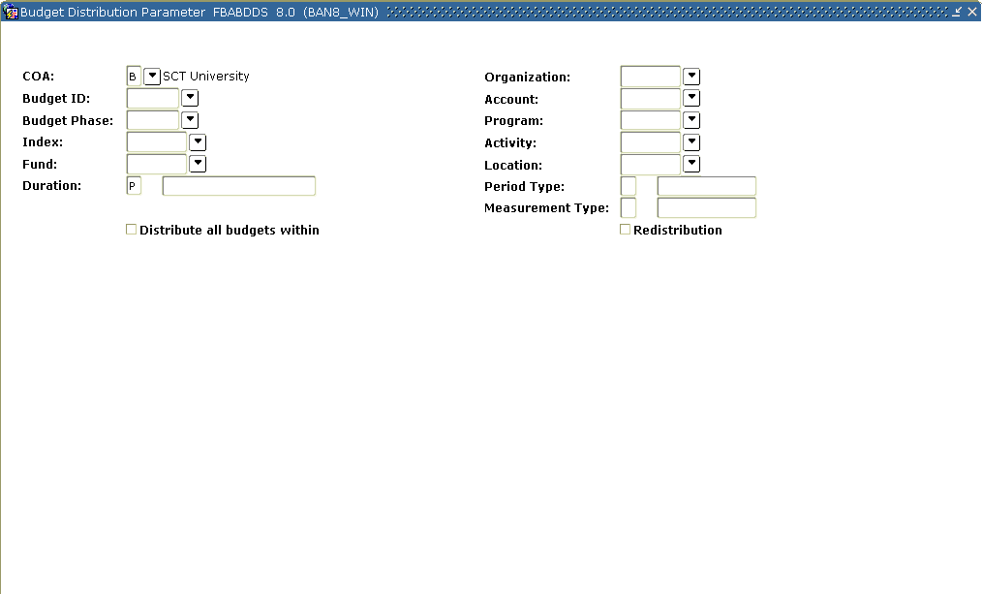

Steps

Follow these steps to complete the process.

1. Access the Budget Distribution Parameter Form (FBABDDS).
2. Enter the budget ID previously created in the **Budget ID** field**.**
3. Enter the phase you wish to roll to the ledger in the **Budget Phase** field (APPRVD).
4. Enter *B* (or the Chart of Accounts code for your institution) in the **COA** field.
5. Move the cursor and check the box that says **Distribute all budgets within.**
6. Move to the Distribution Parameter Information block and enter the following information:

* Enter *1* in the **Start Period** field.
* Enter *1* in the **Number of Periods** field**.**
* Enter *100 f*or the **Distribution%** field.

1. Click the **Save** icon.

Note: Notice the message in the lower left-hand corner of your screen advising you to run the FBRBDDS process.

Budget Distribution Summary Process (FBRBDDS)

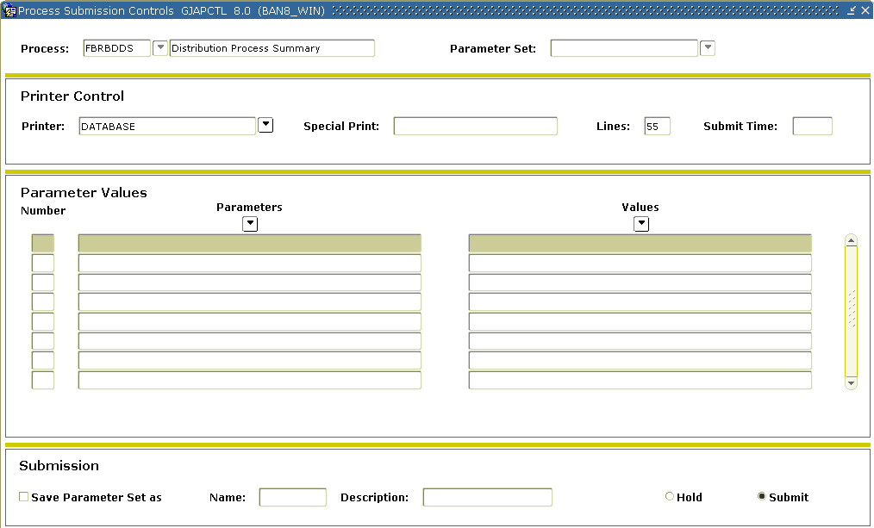

Steps

Follow these steps to complete the process.

1. Access the Budget Distribution Summary Process (FBRBDDS).
2. Navigate to the **Submission** Block.
3. Click the **Save** icon.

Note: Verify that this process has completed before continuing.

Budget Process Control Parameter Form (FBABPRC)

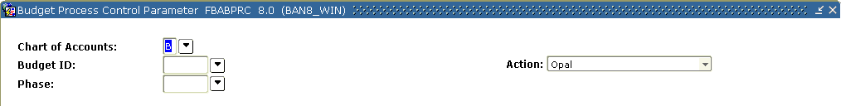

Steps

Follow these steps to complete the process.

1. Access the Budget Process Control Parameter Form (FBABPRC).
2. Enter the budget ID previously created in the **Budget ID** field.
3. Enter *APPRVD* (or your fourth phase name) in the **Phase** field.
4. Enter *B* (or the Chart of Accounts code for your institution) in the **COA** field.
5. Select **Activate** from the drop-down list in the **Action** field.
6. Perform a **Next Block** function to navigate to the Phase Activation Data block.
7. Enter *BD01* in the **Permanent Rule Code** field.
8. Enter *BD03* in the **Temporary Rule Code** field.
9. Enter *100* in the **Percentage Rolled** field.
10. Enter *Null*in the **Re-run Budget Roll** field.
11. Enter *Roll Original Budget FY* in the **Description** field.
12. Click the **Save** icon.

Note: Notice the message in the lower left-hand of your screen advising you to run the FBRBDRL process. This is the Budget Roll Process.

Budget Roll to General Ledger (FBRBDRL)

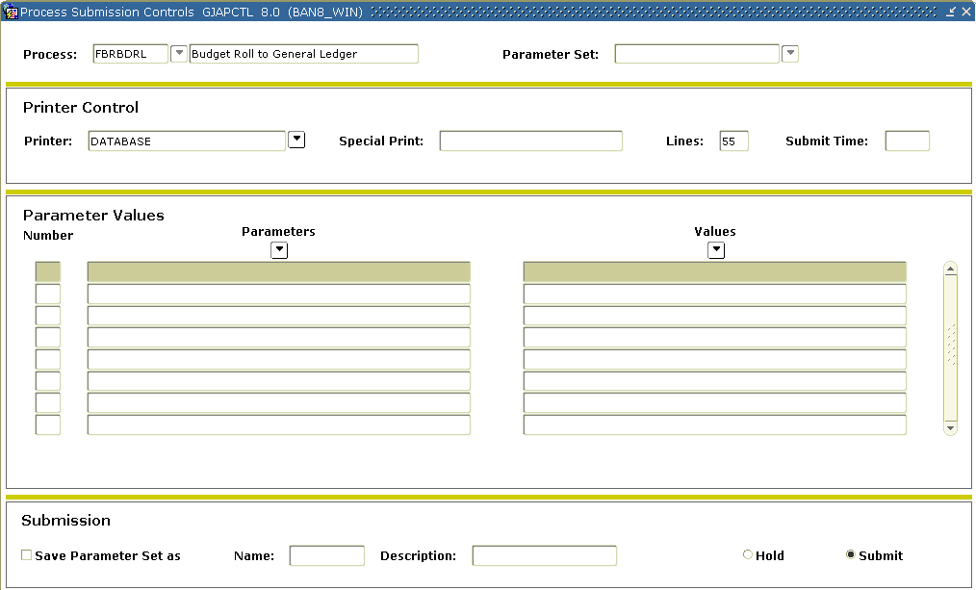

Steps

Follow these steps to complete the process.

1. Access the Budget Roll to General Ledger Form (FBRBDRL).
2. Navigate to the Submission block.
3. Click the **Save** icon.
4. Verify that this process has completed before continuing.
5. Enter FGRTRNI in the **Process** field without leaving the Process Submission Control Form.

Note: This is the Transaction Interface Process.

1. Navigate to the Submission block.
2. Click the **Save** icon.

Viewing and correcting errors

Run the Deferred Edit Error Report (FGRTRNR) to view any errors that may have occurred while trying to roll to the ledger. If errors are encountered, proceed to the next step. If no errors are encountered, proceed directly to the final step in this lesson.

Correct errors in the Budget Development module using the Budget Request By Account Form (FBABDRA) or Budget Request Form (FBABDRQ), depending upon the error. Most errors made will be due to one or more of the FOAPAL elements being non-data enterable or one or more of the FOAPAL elements being terminated.

After making the corrections needed to fix the errors, make sure all phases are closed in the Operating Budget Maintenance Form (FTMOBUD), reenter information in the Budget Distribution Parameter Form (FBABDDS) and run the Budget Distribution Summary Process (FBRBDDS). Then recreate the Budget Process Control Parameter Form (FBABPRC) using action *Activate*, but enter *R* in the **Rerun Budget Roll** field of the Phase Activation Data window. When this is done, rerun the Budget Roll Process (FBRBDRL), the Deferred Edit Report (FGRTRNI), and the Deferred Edit Error Report (FGRTRNR).

Posting process (FGRACTG)

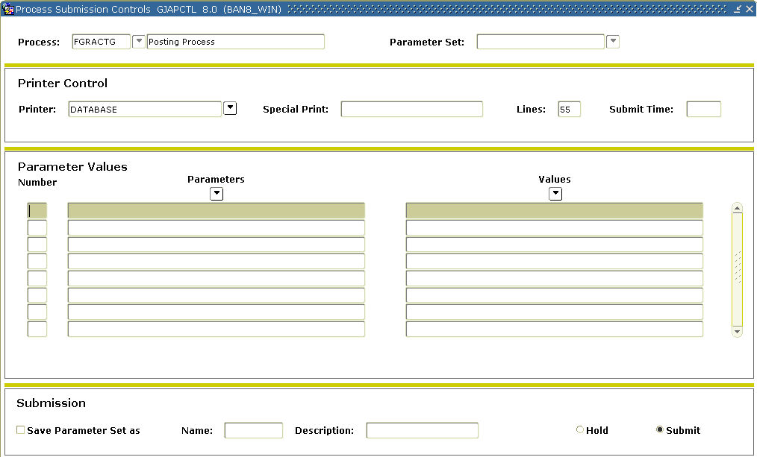

Steps

Follow this step to complete the process.

1. Run the Posting Process (FGRACTG) and confirm the posting(s) using Budget Availability Status Form (FGIBAVL) or the Organization Budget Status Form (FGIBDST).

Self Check



Directions

Use the knowledge you have gained from this training workbook to complete the self check activity below.

Question 1

Why is EBASE the only phase that displays any values?

Question 2

Banner requires that phases be defined by account code.

True or False

Question 3

What do numbers in the **Change Percent** field represent?

Question 4

If you detected problems with the budget when reviewing the budget worksheet, where would you go to update the budget figures?

Question 5

What is the advantage of combining various budget phases or components of the budget into a single phase?

Question 6

Which of these forms (when used together) allow users to roll the approved budget to OPAL?

Fiscal Year Maintenance Form (FTMFSYR)

System Data Maintenance Form (FTMSDAT)

Operating Budget Maintenance Form (FTMOBUD)

Deferred Edit Error Report (FGRTRNR)

All of the above

Answer Key for Self Check



Question 1

Why is EBASE the only phase that displays any values?

**EBASE is the only phase into which we have actually entered budget amounts.**

Question 2

Banner requires that phases be defined by account code.

**False. Phases can represent a step in the budget process, a fund or an organization code, etc.**

Question 3

What do numbers in the **Change Percent** field represent?

**A percentage change to the budget.**

Question 4

If you detected problems with the budget when reviewing the budget worksheet, where would you go to update the budget figures?

**Budgets for individual positions can be updated in NBABUD.**

Question 5

What is the advantage of combining various budget phases or components of the budget into a single phase?

**This provides you with one source for your entire budget, and permits the activation of the entire budget in one step.**

Question 6

Which of these forms (when used together) allow users to roll the approved budget to OPAL?

**All of the above**

Appendix



Forms Job Aid



|  |  |  |
| --- | --- | --- |
| **Form** | **Full Name** | **Use this Form to...** |
| FBABDDA | Budget Distribution by Amount Form | distribute budget amounts to periods by specified dollar amounts. |
| FBABDDS | Budget Distribution Parameter Form | distribute budget amounts to periods by a specified percentage. |
| FBABDRA | Budget Request By Account Form | create new budget requests or change existing requests supporting development of the next fiscal period's budget in an all-encompassing data-entry mode. |
| FBABDRQ | Budget Request Form | enter a budget request for a particular combination of Fund, Organization, Account, Program, Activity, and Location (FOAPAL). |
| FBABPRC | Budget Process Control Parameter Form | set up a parameter record for the required budget action for each phase of the budget process. |
| FBAMCHG | Mass Budget Change Form | make global changes within a specified budget phase. |
| FBIBUDG | Budget Query Form | view comparative budget phase data. |
| FBRBDBB | Budget Build Process | build or change line items for a budget phase. |
| FBRBDRL | Budget Roll Process | roll budget amounts into the Finance Ledgers. |
| FBRFEED | Finance Budget Feed Form | sends Position Control budget information from the Position Control module into the Finance Budget tables. |
| FBRWKSH | Budget Worksheet Report | display up to three budget phases with current year and prior year budget amounts from the budget file. |
| FGRTRNI | Transaction Interface Process | post transactions to the financial ledgers. |
| FGRTRNR | Deferred Edit Error Report | view accounting errors, if there are any. |
| FTMFSYR | Fiscal Year Maintenance Form | establish your fiscal year accounting periods. |
| FTMOBUD | Operating Budget Maintenance Form | create and maintain budget identification and phase data. |
| FTMSDAT | System Data Maintenance Form | maintain information integral to the processing or maintenance of various transactions and/or reports within Finance. |
| NBAPBUD | Position Control Budget | authorizes all positions. It enables you to define position budgets by fiscal year, regular earnings totals (budgeted, encumbered, expended, and remaining), premium earnings totals, fringe benefits, and position labor distributions. |
| NBPBROL | Position Control Budget Roll | execute budget roll (including fringe benefits) from one fiscal year to another. |
| NBRBWRK | Position Control Budget Worksheet | display budget phases with current year and prior year budget amounts from the budget file. This report sorts by organization, fund, program, activity, location, and account. |
| NHPFIN1 | Finance Extract Process | extract data for Finance System interface and update the position totals with encumbered amounts. |
| NHPFIN2 | Finance Interface Report | show information extracted and passed to the Finance System. This report is most useful when you have specific payroll data in your system. |

Terminology



Budget phase

Budget phases may be defined as either components of the budget (revenue, labor, capital, etc.) or as steps in the budget process (initial, requested, approved, 10% increase, etc.).

Chart of accounts

The Chart of Accounts (COA) defines the accounting distribution used on all transactions processed in the Banner Finance module.

Fiscal year

The Fiscal Year is the time period that you create to define the beginning and end of a budget period. Many institutions define their fiscal year as July 1 – June 30.

FOAPAL

An acronym created by the first letter of seven budget elements defined as follows:

**F**und

**O**rganization

**A**ccount

**P**rogram

**A**ctivity

**L**ocation