_______________________________________________________________________________________________

Banner Interface

Banner Human Resources

to Banner Finance

Interface Training Workbook

Release 8.0 – April 2008

Updated 1/18/2013

Prepared by: Ellucian

4375 Fair Lakes Court

Fairfax, Virginia 22033

United States of America

Customer Support Center website

<http://connect.ellucian.com>

Distribution Services e-mail address

[distserv@ ellucian.com](mailto:distserv@sungardhe.com)

Other services

In preparing and providing this publication, Ellucian is not rendering legal, accounting, or other similar professional services. Ellucian makes no claims that an institution's use of this publication or the software for which it is provided will insure compliance with applicable federal or state laws, rules, or regulations. Each organization should seek legal, accounting and other similar professional services from competent providers of the organization's own choosing.

Trademark

Banner®, Colleague®, PowerCAMPUS®, Luminis® and Datatel® are trademarks of Ellucian or its affiliates and are registered in the U.S. and other countries. Ellucian, Advance, Recruiter, and Open Digital Campus are trademarks of Ellucian or its affiliates. Other names may be trademarks of their respective owners.

Revision History Log

|  |  |
| --- | --- |
| Publication Date | Summary |
| 4/30/2008 | New version that supports Human Resources Banner 8.0 software. |
| 1/27/2009 | Removed lessons on setting up position budget, defining benefits/deductions, and establishing earning codes. |
| 2/3/2009 | Added details for rule classes and suggested payroll rule codes. |
| 6/5/2009 | Made correction to Option A |
| 8/24/09 | Changed Page breaks to make reading easier. |
| 6/30/2011 | Fixed HEEL, HERL description and Employee Liability rule. |
| 12/29/2011  1/18/2013 | Changes made by Finance Consultant Rick Gerry and converted to new workbook template.  Corrected wording of Re-Class to recast |

Notice of rights

Copyright © Ellucian 2004-2012.

This document is proprietary and confidential information of one or more of the Ellucian companies and is not to be copied, reproduced, lent, displayed used or distributed except under license from Ellucian.  Third party copy centers are advised that clients of Ellucian that have licensed the underlying technology associated with this documentation have a valid license to copy and use this documentation in accordance with that underlying license.

green

Table of Contents



Introduction 4

Process Introduction 6

Set Up 8

Defining Transaction Rules 9

Tips for Interface Set-Up 17

Day-to-Day Operations 18

Extracting Payroll Data 19

Reviewing Extracted Information 22

Testing Rule Codes 25

Reviewing Document Postings 27

Correcting Errors 29

Payroll Interface to Banner Finance: Suggested Payroll Rule Codes 31

Self Check 39

Answer Key 41

Appendix 43

Forms Job Aid 44

Introduction



Course goal

This goal of this workbook is to delineate Banner’s support for the Human Resources to Finance Interface process.

The workbook is divided into these sections:

* Introduction
* Set Up
* Day-to-Day Operations

Course objectives

In this course, you will learn how to

* set up transaction rules
* set up the Human Resources to Finance Interface process
* extract payroll data
* review extracted information
* test rule codes
* review document postings
* correct errors

Intended audience

Personnel responsible for the Human Resources to Finance Interface process at your institution.

Prerequisites

To complete this course, you should have

* completed the Education Practices computer-based training (CBT) tutorial *Banner 8 Fundamentals*, or have equivalent experience navigating in the Banner system
* administrative rights to create and perform the necessary set up in Banner
* completed the Finance: Chart of Accounts workbook
* completed the Finance: Rules, Security and Approvals workbooks
* a minimum working knowledge of SQL for building rules.

Process Introduction



Introduction

This workbook is intended to train designated personnel in the use of the Banner Human Resources to Finance Interface, as a tool to accomplish administrative responsibilities in managing the interface that posts Human Resources transactions to the Finance System.

Flow diagram

This diagram highlights steps for feeding Banner Human Resources data to Banner Finance.

Note: Some steps may be completed by different offices at your institution.



What happens?

The stages of the process are described in this table.

|  |  |
| --- | --- |
| Stage | Description |
| **Finance Office** | |
| 1 | Sets up and reviews rule codes and posting examples. |
| 2 | Sets up the HR/Finance Set Up Rule Form (NTRFINI). |
| **Human Resources Office** | |
| 3 | Feeds HR Transactions to the Generic Interface table (GURFEED). |
| **Finance Office** | |
| 4 | Runs the Finance Feed Sweep process (FURFEED), which feeds transactions from GURFEED to the Interface table (FGBTRNI) and feeds Position Budgets from GURFEED to the Finance Budget tables. |
| 5 | Runs the Interface process (FGRTRNI) to create journal entries and populate either the approved posting table (if no errors) or the Suspended Journal File (if errors are detected). |
| 6 | Runs the Transaction Error Report (FGRTRNR) to purge the Interface table (FGBTRNI) and produce an error report. |
| 7 | Runs the Posting process (FGRACTG) to post approved entries to the Finance Ledgers. |

Set Up



Section goal

The goal of this section is to outline the set-up process and detail the procedures to set-up the Human Resources to Finance Interface process at your institution.

Objectives

At the end of this section, you will be able to

* set up transaction rules
* set up the Human Resources to Finance Interface process.

Defining Transaction Rules



Introduction

To feed the Human Resources transactions to the Finance System, you must define interface transaction rules using the HR/Finance Set Up Rule Form (NTRFINI). This form is used to establish interface transaction rules, define accounting distribution for net pay and deferred pay, as well as for fringe clearing and validate rule class codes against the Finance System Rules Maintenance Form (FTMRUCL).

Banner form

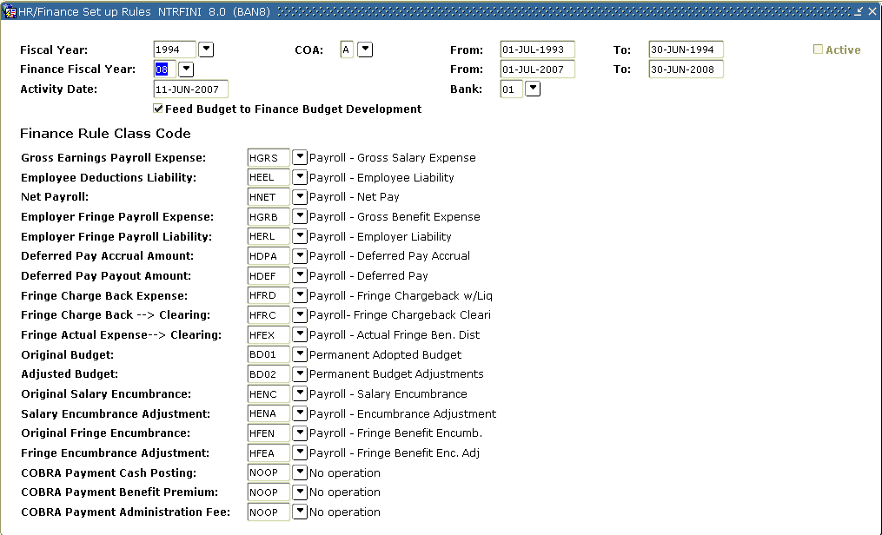

Steps

Follow these steps to complete the process.

1. Access the HR/Finance Set Up Rule Form (NTRFINI).
2. Note: When you access this form, all defined records are retrieved.
3. To view all of the Finance rule class code fields, use the vertical scroll box located to the right or perform a Next Item function.
4. Enter the fiscal year for which you are setting up the interface in the Fiscal Year field.

Notes: The system displays the year’s start and end dates in the From and To fields. The value you enter in the Fiscal Year field must be predefined on the Fiscal Year Form (NBAFISC)

1. The COA field displays the Chart of Accounts code to be applied to the labor distributions, as found in the Distribution Information window.
2. The Active checkbox indicates whether the value entered in the Fiscal Year field is defined as the currently active fiscal year on the Fiscal Year Form (NBAFISC).
3. Enter the Finance System fiscal year for which you are setting up the interface in the Finance Fiscal Year field.

Note: The system displays the year’s start and end dates in the From and To fields. The end date should match the end date that appears for the Human Resources fiscal year. The value you enter must be predefined on the Finance Fiscal Year Form (FTMFSYR).

1. Enter the code of the bank you use to issue payroll checks and direct deposits in the Bank field.

Note: The bank code must be defined on (GXRBANK).

1. The Feed Budget to Finance Budget Development checkbox is used to update the Banner Finance Budget Development module with all original and adjusted budget entries for both working and active salary and fringe budgets.
2. The Finance Rule Class Code section is used to enter the Banner Finance System rule class codes that the system should use for validation.

Note: The codes you enter must be predefined on the Finance System’s Rules Maintenance Form (FTMRUCL).

For Example:

**When Recast is Used:**

|  |  |
| --- | --- |
| Gross Earnings Payroll Expense: | HGNL |
| Employee Deductions Liability: | HEEL (payroll deductions) |
| Net Payroll: | HNET |
| Employer Fringe Payroll Expense: | HGRB if fringe actual  HFNL if fringe chargeback but not encumbering  HFRD if fringe chargeback and encumbering |
| Employer Fringe Payroll Liability: | HERL (employee benefit and tax liability) |
| Deferred Pay Accrual Amount: | HDPA if processing deferred pay  NOOP if not processing deferred pay |
| Deferred Pay Payout Amount: | HDEF if processing deferred pay  NOOP if not processing deferred pay |
| Fringe Charge Back Expense: | HFRD if encumbering fringes  HNFL if not encumbering fringes  NOOP if using the actual expense method for fringes |
| Fringe Charge Back --> Clearing: | HFRC if processing fringe charge back  NOOP if fringe actuals |
| Fringe Actual Expense --> Clearing: | HFEX if processing fringe charge back  NOOP if fringe actuals |
| Original Budget: | BD01 or client built rule class code depending on required functionality in transferring position budget additions an changes to the Finance Operating Ledger  NOOP if not posting to the Finance Operating Ledger |
| Adjusted Budget: | BD02 or client built rule class code depending on required functionality in transferring position budget additions an changes to the Finance Operating Ledger  NOOP if not posting to the Finance Operating Ledger |
| Original Salary Encumbrance: | HENC if encumbering (This creates the original encumbrance)  NOOP if not encumbering |
| Salary Encumbrance Adjustment: | HENA if encumbering  NOOP if not encumbering |
| Original Fringe Encumbrance: | HFEN if encumbering  NOOP if not encumbering |
| Fringe Encumbrance Adjustment: | HFEA if encumbering  NOOP if not encumbering |
| COBRA Payment Cash Posting: | HCBC if processing COBRA cash receipts through Banner HR  NOOP if not |
| COBRA Payment Benefit Premium: | HCBP if processing COBRA cash receipts through Banner HR  NOOP if not |
| COBRA Payment Administration Fee: | HCBA if processing COBRA cash receipts through Banner HR  NOOP if not |

**When Recast is Not Used:**

|  |  |
| --- | --- |
| Gross Earnings Payroll Expense: | HGRS |
| Employee Deductions Liability: | HEEL (payroll deductions) |
| Net Payroll: | HNET |
| Employer Fringe Payroll Expense: | HGRB if fringe actual  HFNL if fringe chargeback but not encumbering  HFRD if fringe chargeback and encumbering |
| Employer Fringe Payroll Liability: | HERL (employee benefit and tax liability) |
| Deferred Pay Accrual Amount: | HDPA if processing deferred pay  NOOP if not processing deferred pay |
| Deferred Pay Payout Amount: | HDEF if processing deferred pay  NOOP if not processing deferred pay |
| Fringe Charge Back Expense: | HFRD if encumbering fringes  HNFL if not encumbering fringes  NOOP if using the actual expense method for fringes |
| Fringe Charge Back --> Clearing: | HFRC if processing fringe charge back  NOOP if fringe actuals |
| Fringe Actual Expense --> Clearing: | HFEX if processing fringe charge back  NOOP if fringe actuals |
| Original Budget: | BD01 or client built rule class code depending on required functionality in transferring position budget additions an changes to the Finance Operating Ledger  NOOP if not posting to the Finance Operating Ledger |
| Adjusted Budget: | BD02 or client built rule class code depending on required functionality in transferring position budget additions an changes to the Finance Operating Ledger  NOOP if not posting to the Finance Operating Ledger |
| Original Salary Encumbrance: | HENC if encumbering (This creates the original encumbrance)  NOOP if not encumbering |
| Salary Encumbrance Adjustment: | HENA if encumbering  NOOP if not encumbering |
| Original Fringe Encumbrance: | HFEN if encumbering  NOOP if not encumbering |
| Fringe Encumbrance Adjustment: | HFEA if encumbering  NOOP if not encumbering |
| COBRA Payment Cash Posting: | HCBC if processing COBRA cash receipts through Banner HR  NOOP if not |
| COBRA Payment Benefit Premium: | HCBP if processing COBRA cash receipts through Banner HR  NOOP if not |
| COBRA Payment Administration Fee: | HCBA if processing COBRA cash receipts through Banner HR  NOOP if not |

1. Click the **Save** icon.

Options - Distribution

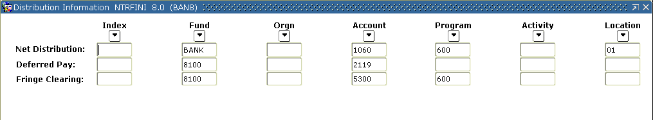

Steps

1. Select **Distribution** from the **Options** menu.
2. Use the Net Distribution row to indicate the fund and account to be used in the interface.

Notes: The the **Fund** field, should be the bank fund, and the **Acct** field, a general ledger account code. If using Option A, it should be the cash account. If using option B or C it should be the Payroll Clearing Account.

1. Use the Deferred Pay row to indicate the FOAPAL deferred pay distribution to be used in the interface.

Note: The only fields that should contain values are the **Fund** and **Acct** fields, which contain the fund and account used for the accrual of deferred pay liability.

1. Use the Fringe Clearing row to enter the accounting distribution where the actual fringe expense will be debited and the fringe charge-back amount will be credited.
2. Click the **Save** icon.
3. Click the **Exit** icon.

Options - Fringe Rules

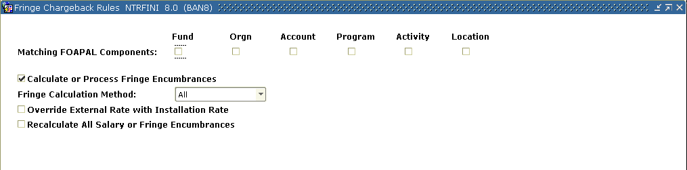

1. Select **Fringe Rules** from the **Options** menu.
2. Use the Matching FOAPAL Components row to specify which components of the FOAPAL are to be considered in the matching of internal funding sources. The values you enter will guide the fringe encumbrance and expense process.
3. The values you select for the **Calculate/Process Fringe Encumbrances** checkbox, the **Fringe Calculation Method** pull-down list, and the **Override External Rate with Installation Rate?** checkbox are used to determine how to encumber, liquidate encumbrances, and expense fringe benefits.

Note: Refer to Chapter 7 of the **Human Resources User Manual** for a review of these options.

1. The **Recalculate All Salary or Fringe Encumbrances?** checkbox is enabled when you make changes for this fiscal year to the Fringe Rate Definition and Labor Distribution Override Rule Form (NTRFBLD).

Note: The next time the Budget Maintenance process (NBPBUDM) is run in Process mode, this option is disabled.

1. Click the **Save** icon.
2. Click the **Exit** icon to close the window.
3. We will not be demonstrating the **Copy Prior Year** option. To use this feature, you would select this option, select the record for the year you want to bring forward, and click **OK**.
4. Click the **Exit** icon.

Tips for Interface Set-Up



Set-up tips

If you choose to use the charge-back method, residual fringes (the difference between the actual fringes calculated and the calculated percentage charged to the department) are posted to a Fringe Clearing account defined on the HR/Finance Set Up Rule Form (NTRFINI). This account may be either a G/L or Operating account. It is recommended that you use an Operating account so that the expense is recognized immediately without manual intervention (i.e. a journal entry being written).

Regardless of the method, ALL of the Labor Distribution accounting entries on the Benefit/Deduction Rule Form (PTRBDCA) should be set up. To verify that this is done, use the following calculation:

[number of employee classes] X [number of benefit/deduction codes] = number of records in each of the ACCT fields in the PTRBDLD table

In instances where a given Employee class is not eligible for a particular benefit or deduction, it is STRONGLY RECOMMENDED that you enter a Suspense account instead of leaving it blank.

Posting modifiers bypass normal System edits, so it is imperative that all of these Rule codes be fully tested before they are used in a production environment.

On the Payroll Adjustment Form (PHAADJT) there are two date fields. The Payroll date affects payroll history and tax records and should reflect the Effective date (Date of Constructive Receipt) of the adjustment for payroll purposes. The Posting date is what is fed as the Transaction date to Finance and should always be the System date (exceptions may be made at the end of the fiscal year).

For Rule code *HEEL*, some organizations may credit employee deductions directly to an Operating account. An example would be if employees pay for parking permits via payroll deduction, with the revenue being credited directly to the Parking Department. In that case, the edit on the ACCT_CODE field of *4450* whould be removed and the additions of these process codes: O030, G020, and a reverse G020 with a posting modifier to the payroll clearing fund.

Day-to-Day Operations



Section goal

The goal of this section is delineate day-to-day or operational procedures required to run the Human Resources to Finance Interface process.

Objectives

At the end of this section, you will be able to

* extract payroll data
* review extracted information
* test rule codes
* review document postings
* correct errors

Extracting Payroll Data



Introduction

When processing encumbrances, payroll expenditures, and approved budget transactions, the user is required to run the Expenditures Finance Extract process (PHPFEXP). PHPFEXP puts identical sets of information in the Finance Interface Collector table (NHRFINC) and the Finance Distribution table (NHRDIST) for encumbrances, payroll expenditures, and budgets.

For working budgets, PHPFEXP puts identical sets of information into NHRFINC and the Temporary Budget table (NHRTBUD). PHPFEXP aids in the preparation of all the tables for the eventual insertion of the Finance Document number by the Finance Interface Report (NHPFIN2).

This process also updates the expended amounts on the Position Budget Form (NBAPBUD)

Banner form

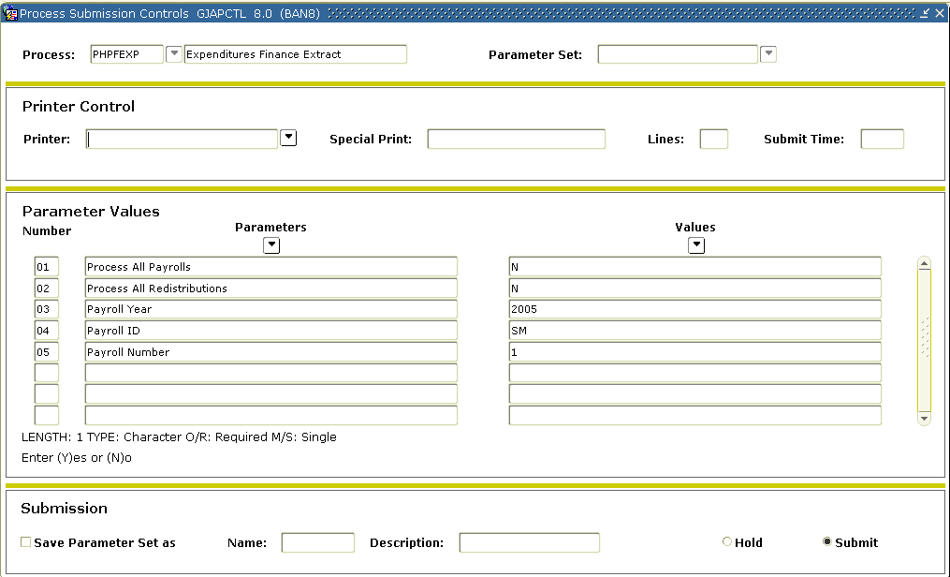

Steps

Follow these steps to complete the process.

1. Access the Process Submission Control Form (GJAPCTL).
2. Enter *PHPFEXP* (Expenditures Finance Extract process) in the **Process** field.

Note: This process extracts payroll data for interface to the Finance System and updates the expended amounts on the Position Definition Form (NBAPOSN).

1. Perform a **Next Block** function.
2. Enter the desired printer name in the **Printer** field.

Note: You can enter *DATABASE* to write the report to a table for on-line viewing and to enable the saving of the report to a shared folder on a designated network drive.

1. The **Print** field displays the number of printed lines per inch. If you direct your output to a database, you can leave this field blank.
2. Enter these parameter values.

|  |  |
| --- | --- |
| Parameter | Value |
| Process All Payrolls (required) | Enter *Y* to process all payrolls awaiting Finance Extract processing; enter *N* if you don’t want to process all payrolls. |
| Process All Distributions (required) | Enter *Y* to process redistributions for all payrolls awaiting Finance Extract processing; enter *N* if you do not want to process all redistributions. |
| Payroll Year | Enter the payroll year. |
| Payroll ID | Enter the ID of the payroll to be included in the report. |
| Payroll Number | Enter the Period number of the payroll to be included in the report. |

1. Click the **Save Parameter Set as** checkbox.
2. Enter a name and description in the **Name** and **Description** fields.
3. Click the **Submit** radio button.
4. Click the **Save** icon to execute the report.

Result: The Auto hint line displays the job submission number for the report log and list file.

1. Select **Review Output** on the **Options** menu to review the report.
2. Click the **Exit** icon.

Reviewing Extracted Information



Introduction

The Finance Interface Report process (NHPFIN2) associates the Finance Document number with a specific payroll in the Generic Interface table (GURFEED). In addition, the Document number is inserted into the Finance Distribution table (NHRDIST), and the Temporary Budget table (NHRTBUD).

Banner form

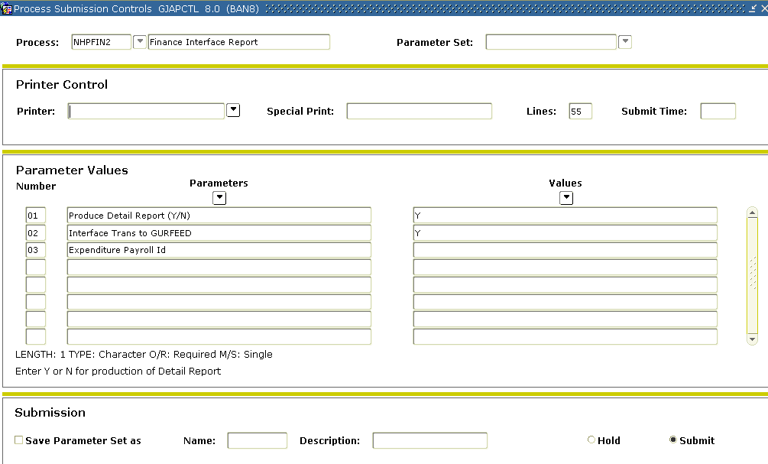

Steps

Follow these steps to complete the process.

1. Access the Process Submission Control Form (GJAPCTL).
2. Enter the Finance Interface Report process (NHPFIN2).

Note: This process shows information that has been passed to the Finance System.

1. Perform a **Next Block** function.
2. Enter the desired printer name in the **Printer** field.

Note: You can enter *DATABASE* to write the report to a table for on-line viewing and to enable the saving of the report to a shared folder on a designated network drive.

1. The **Print** field displays the number of printed lines per inch. If you direct your output to a database, you can leave this field blank.
2. Enter these parameter values.

|  |  |
| --- | --- |
| Parameter | Value |
| Produce Detail Report (required) | Enter *Y* if you want to create the Detail Finance Interface Report; enter *N* to override the Detail Finance Interface Report. |
| Interface Trans to GURFEED (required) | Enter *Y* to interface transactions to the Finance System from the Position Control module; enter *N* to override the interface to the Finance System from the Position Control module. |
| Expenditure to Payroll ID | Enter a Payroll ID code if expenditure data will be interfaced. |

1. Click the **Save Parameter Set as** checkbox.
2. Enter a name and description in the **Name** and **Description** fields.
3. Click the **Submit** radio button.
4. Click the **Save** icon to execute the report.

Result: The Auto hint line displays the job submission number for the report log and list file.

1. Select **Review Output** on the **Options** menu to review the report.
2. Click the **Exit** icon.

Testing Rule Codes



Introduction

The most important thing to remember is to test the rule codes, which are organization specific. If you don’t have any real payroll data, we can still test using a journal voucher. In this exercise, we select payroll rule codes using the Fringe Actual Method. This method is the System default.

Banner form

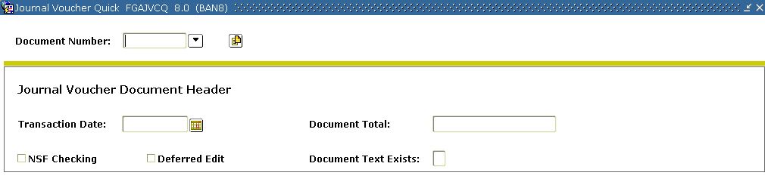

Steps

Follow these steps to complete the process.

1. Access the Journal Voucher Quick Form (FGAJVCQ).
2. Enter *NEXT* in the **Document Number** field.

Note: Banner will assign a Document number.

1. Perform a **Next Block** function.
2. Enter today’s date in the **Transaction Date** field.
3. Enter the document total for the journal line items in the **Document Total** field.
4. Perform a **Next Block** function.
5. Record the Document number that was assigned to the transaction.
6. Press the **[Tab]** key and Banner will enter the next **Sequence** number for the document. For this exercise, Banner will enter *1*.
7. Complete the other fields as directed by your instructor.
8. Click the **Save** icon.
9. Click the **Exit** icon.

Reviewing Document Postings



Introduction

All documents that are posted to the ledger can be viewed on the Document Inquiry Review Form (FGIDOCR).

Banner form

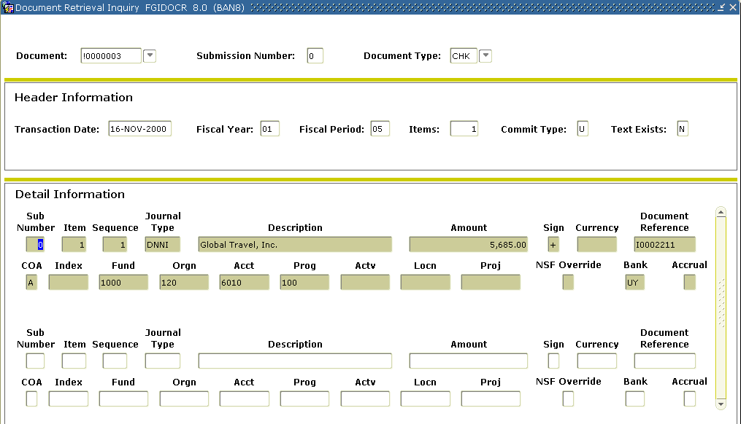

Steps

Follow these steps to complete the process.

1. Access the Document Retrieval Inquiry Form (FGIDOCR).
2. Enter the document number previously assigned to the transaction in the **Document Number** field.
3. Perform a **Next Block** function.

Note: The journal header record reflects the actual items that were entered on the journal voucher.

Option - Document Postings

Next, you may view the detail postings.

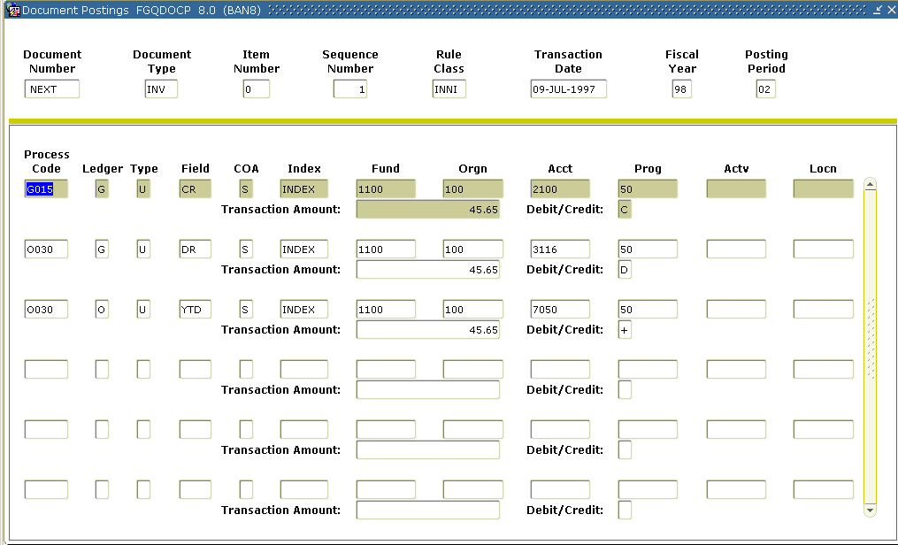

1. Select **Access Document Postings** from the **Options** menu to view the detail postings on the Document Posting Form (FGQDOCP).
2. Click the **Exit** icon to return to the Document Retrieval Inquiry Form (FGIDOCR).
3. Click the **Exit** icon.

Correcting Errors



Introduction

Any documents listed on the Document Retrieval Inquiry Form (FGIDOCR) were probably rolled back and reset during posting.

Banner form

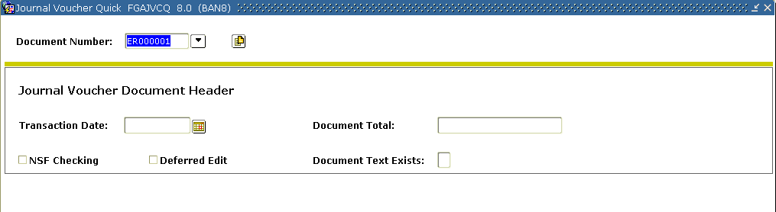

Steps

Follow these steps to complete the process.

1. Access the Journal Voucher Quick Form (FGAJVCQ).
2. Click the **Search** icon to the right of the **Document Number** field.
3. Select the document you wish to correct from the List of Suspended Journal Vouchers Form (FGIJVCD). This loads the document into the Journal Voucher Quick Form (FGAJVCQ).

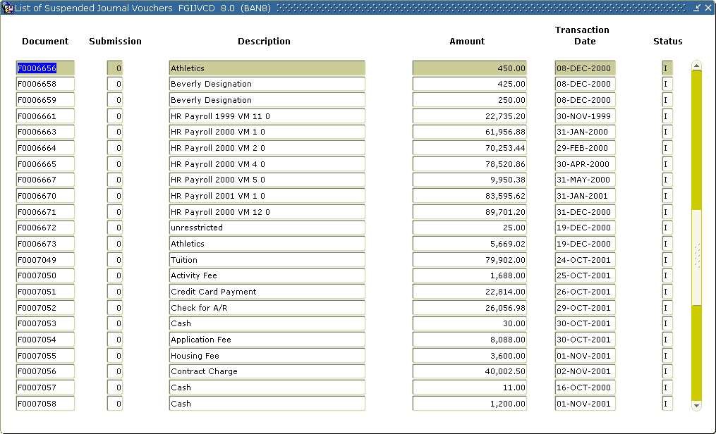

1. Perform a **Next Block** function.
2. Double-click the **Document Total** field and use the calculator to enter a new value.
3. Click the **Save** icon.
4. Click the **Exit** icon.
5. Post the transaction.

Note: If you are not sure of the errors, check the posting .lis file which will provide information as to why it didn’t post.

Payroll Interface to Banner Finance: Suggested Payroll Rule Codes



Option A – Fringe Actual Method (System Default with limited posting modifiers)

|  |  |  |  |  |  |  |  |
| --- | --- | --- | --- | --- | --- | --- | --- |
| Rule | Account Description | Balance Method | Edits | Process Codes | Posting Action | Posting Modifier | |
| **Fund** | **Acct** |
| HEEL | Employee Liability | S | ACCT_CODE 4450 | I061 | N |  |  |
| G010  G020 | N  N | P/R Clearing  P/R Clearing |
| G022 | N |  |
| G026 | R |  | Payroll Clearing |
| HENC  HENA | Salary Encumbrance  Salary Encumbrance Adj. | S | ACCT_CODE 4451 | I011  E117 | N  N |  |  |
| HERL | Employer Liability | S | ACCT_CODE 4450 | I061 | N |  |  |
| G010  G020  G022 | N  N  N | P/R Clearing  P/R Clearing |
| G026 | R |  | Payroll Clearing |
|  |  |  |  |  |  |  |  |
|  |  |  |  |
|  |  |  |  |
|  |  |  |  |
|  |  |  |  |
| HGRB | Employer-paid Benefits | S | ACCT_CODE 4451 | I061 | N |  |  |
| O030 | N |  |  |
|  |  |  |  |
| G020  G022 | N  N |  |  |
| G026 | R |  | Payroll Clearing |
| HGRS | Gross Payroll Expense | S | ACCT_CODE 4451 | I061  O030  E035  G020  G022  G026 | N  N  N  N  N  R |  | Payroll Clearing |
| HNET | Net Payroll | S | ACCT_CODE 4450 | I061 | N |  |  |
| G024 | N |  |
|  |  |  |  |
|  |  |  |  | G026 | R |  | Payroll Clearing |

Out of the box, the system delivered rules codes need a payroll clearing account posting modifier on the G026 process. The posting modifiers on the G010 and G020 process in HEEL and HERL allow the liability accounts to post to a single fund.

|  |  |  |  |  |  |  |  |
| --- | --- | --- | --- | --- | --- | --- | --- |
| **IF YOU DO NOT ENCUMBER SALARIES:** | | | | | | | |
| If gross salaries are not encumbered, replace the HGRS Gross Payroll Expense rule with HGNL Gross Payroll No Liquidation rule. The only difference is that HGNL does not have an E035 process code. | | | | | | | |
|  | | | | | | | |
| HGNL | Payroll-Gross Exp. No Liquidation | S | ACCT_CODE 4451 | I061 | N |  |  |
| O030 | N |
| G020 | N |
| G022 | R |  |
| G026 | R |  | Payroll Clearing |

Option B – Fringe Actual Method using Payroll Clearing Fund

|  |  |  |  |  |  |  |  |
| --- | --- | --- | --- | --- | --- | --- | --- |
| Rule | Account Description | Balance Method | Edits | Process Codes | Posting Action | <------Modifiers-------> | |
| **Fund** | **Account** |
| HEEL | Employee Liability | S | ACCT_CODE 4450 | I061 | N |  |  |
| G010 | N | P/R Clearing |
| G010 | R | P/R Clearing | Payroll Clearing |
| HENC | Salary Encumbrance | S | ACCT_CODE 4451 | I011 | N |  |  |
| HENA | Salary Encumbrance Adj. | E117 | N |
| HERL | Employer Liability | S | ACCT_CODE 4450 | I061 | N |  |  |
| G010 | N | P/R Clearing |
| G010 | R | P/R Clearing | Payroll Clearing |
| HGRB | Employer-paid Benefits | S | ACCT_CODE 4451 | I061 | N |  |  |
| O030 | N |
| G020 | N |
| G020 | R | P/R Clearing |
| G010 | R | P/R Clearing | Payroll Clearing |
| HGRS | Gross Payroll Expense | S | ACCT_CODE 4451 | I061 | N |  |  |
| O030 | N |
| E035 | N |
| G020 | N |
| G020 | R | P/R Clearing |
| G010 | R | P/R Clearing | Payroll Clearing |
| HDPA | Deferred Pay Accrual | S | ACCT_CODE 4450 | I061 | N |  |  |
| G010 | N |
| G010 | R | Payroll Clearing |
| HDEF | Deferred Pay Payout | S | ACCT_CODE 4450 | I061 | N |  |  |
| G010 | N |
| G010 | R | Payroll Clearing |
| HNET | Net Payroll | S | ACCT_CODE 4450 | I061 | N |  |  |
| G010 | R | P/R Clearing | Payroll Clearing |
| G020 | R | P/R Clearing |  |
| G023 | N |  |
| G024 | N |
|  |  |  |  |  |  |  |  |
| **IF YOU DO NOT ENCUMBER SALARIES** | | | | | | | |
| If gross salaries are not encumbered, replace the HGRS Gross Payroll Expense rule with HGNL Gross Payroll No Liquidation rule. The only difference is that HGNL does not have an E035 process code. | | | | | | | |
|  | | | | | | | |
| HGNL | Payroll-Gross Exp. No Liquidation | S | ACCT_CODE 4451 | I061 | N |  |  |
| O030 | N |
| G020 | N |
| G020 | R | P/R Clearing |
| G010 | R | P/R Clearing | Payroll Clearing |

Option C – Fringe Chargeback Method using Payroll Clearing Fund

|  |  |  |  |  |  |  |  |
| --- | --- | --- | --- | --- | --- | --- | --- |
| Rule | Account Description | Balance Method | Edits | Process Codes | Posting Action | <------Modifiers-------> | |
| **Fund** | **Account** |
| HEEL | Employee Liability | S | ACCT_CODE 4450 | I061 | N |  |  |
| G010 | N | P/R Clearing |  |
| G010 | R | P/R Clearing | Payroll Clearing |
| HENC | Salary Encumbrance | S | ACCT_CODE 4451 | I011 | N |  |  |
| E117 | N |
| HFEN | Fringe Encumbrance | S | ACCT_CODE 4451 | I011 | N |  |  |
| E117 | N |
| HERL | Employer Liability | S | ACCT_CODE 4450 | I061 | N |  |  |
| G010 | N | P/R Clearing |
| G020 | N | P/R Clearing |
| HFRD | Fringe Chargeback with liquidation of encumbrance | S |  | I061 | N |  |  |
| O030 | N |
| G020 | N |
| E035 | N |
| HFRC | Fringe Chargeback Clearing | S |  | I061 | N |  |  |
| O030 | N |
| G020 | N |
| G010 | N |
| HFEX | Fringe Actual Distribution | S |  | I061 | N |  |  |
| O030 | N |
| G020 | N |
| G010 | N |
| HENA | Salary Encumbrance Adj. | S |  | I061 | N |  |  |
| E020 | N |
| HFEA | Fringe Encumbrance Adj. | S |  | I061 | N |  |  |
| E020 | N |
| HGRS | Gross Payroll Expense | S | ACCT_CODE 4451 | I061 | N |  |  |
| O030 | N |  |
| E035 | N |  |  |
| G020 | N | P/R Clearing  P/R Clearing | Payroll Clearing |
| G020 | R |
| G010 | R |

Option C – Fringe Chargeback Method using Payroll Clearing Fund - Continued

|  |  |  |  |  |  |  |  |
| --- | --- | --- | --- | --- | --- | --- | --- |
| Rule | Account Description | Balance Method | Edits | Process Codes | Posting Action | <------Modifiers-------> | |
| **Fund** | **Account** |
| HDPA | Deferred Pay Accrual | S | ACCT_CODE 4450 | I061 | N |  |  |
| G010 | N |  |
| G010 | R | Payroll Clearing |
| HDEF | Deferred Pay Payout | S | ACCT_CODE 4450 | I061 | N |  |  |
| G010 | N |  |
| G010 | R | Payroll Clearing |
| HNET | Net Payroll | S | ACCT_CODE 4450 | I061 | N |  |  |
| G010 | R | P/R Clearing | Payroll Clearing |
| G020 | R | P/R Clearing |  |
| G023 | N |
| G024 | N |
|  |  |  |  |  |  |  |  |
| **IF YOU DO NOT ENCUMBER SALARIES** | | | | | | | |
| If gross salaries are not encumbered, replace the HGRS Gross Payroll Expense rule with HGNL Gross Payroll | | | | | | | |
| No Liquidation rule. The only difference is that HGNL does not have an E035 process code. | | | | | | | |
| HGNL | Payroll-Gross Exp. No Liquidation | S | ACCT_CODE 4451 | I061 | N | P/R Clearing  P/R Clearing |  |
| O030 | N |
| G020 | N |
| G020 | N |
| G020 | R | Payroll Clearing |

Postings using Option A

Fringe Actual Method (System Default)

Pay salary of $100, employer-paid fringes of $20, and deductions of $15.

The journal voucher fed by Banner Payroll looks like this:

|  |  |  |  |
| --- | --- | --- | --- |
| Dr. | Salary Expens | $100 | HGRS (a) |
| Dr. | Fringe Expense | 20 | HGRB (b) |
| Cr. | Employer Fringe Liab. | 20 | HGRB (c) |
| Cr. | Employee Fringe Liab. | 15 | HEEL (d) |
| Cr. | Net Pay | 85 | HNET (e) |

Fund Realizing Payroll Expense

|  |  |  |  |  |  |  |  |
| --- | --- | --- | --- | --- | --- | --- | --- |
| **Cash Interfund** | |  | **Salary Expense** | |  | **Fringe Expense** | |
|  | 100(a)  20(b) |  | 100(a) |  |  | 20(b) |  |

Payroll Clearing Fund

|  |  |  |  |  |  |  |  |
| --- | --- | --- | --- | --- | --- | --- | --- |
| **Cash Interfund** | |  | **Payroll Clearing** | |  | **Fringe Liability** | |
| 15(d)  20(c) |  |  |  |  |  |  | 15(d)  20(c) |

Bank Fund

|  |  |  |  |  |  |  |  |
| --- | --- | --- | --- | --- | --- | --- | --- |
| **Cash Interfund** | |  | **Payroll Clearing** | |  | **Payroll Cash** | |
| 100(a)  20(b) | 15(d)  20(c) |  | 15(d)  20(c)  85(e) | 100(a)  20(b) |  |  | 85(e) |

Postings using Option B

Fringe Actual Method using Payroll Clearing Fund

Pay salary of $100, employer-paid fringes of $20, and deductions of $15.

The journal voucher fed by Banner Payroll looks like this:

|  |  |  |  |
| --- | --- | --- | --- |
| Dr. | Salary Expense | 100 | HGRS (a) |
| Dr. | Fringe Expense | 20 | HGRB (b) |
| Cr. | Employer Fringe Liab. | 20 | HERL (c) |
| Cr. | Employee Fringe Liab. | 15 | HEEL (d) |
| Cr. | Net Pay | 85 | HNET (e) |

Fund Realizing Payroll Expense

|  |  |  |  |  |  |  |  |
| --- | --- | --- | --- | --- | --- | --- | --- |
| **Cash Interfund** | |  | **Salary Expense** | |  | **Fringe Expense** | |
|  | 100(a)  20(b) |  | 100(a) |  |  | 20(b) |  |

Payroll Clearing Fund

|  |  |  |  |  |  |  |  |
| --- | --- | --- | --- | --- | --- | --- | --- |
| **Cash Interfund** | |  | **Payroll Clearing** | |  | **Fringe Liability** | |
| 100(a)  20(b) | 85(e) |  | 20(c)  15(d)  85(e) | 100(a)  20(b) |  |  | 20(c)  15(d) |

Bank Fund

|  |  |  |  |  |  |  |  |
| --- | --- | --- | --- | --- | --- | --- | --- |
| **Cash Interfund** | |  | **Payroll Clearing** | |  | **Payroll Cash** | |
| 85(e) |  |  |  |  |  |  | 85(e) |

Postings using Option C

Fringe Chargeback Method using Payroll Clearing Fund

Pay salary of $100, employer-paid fringes of $20, chargeback percent of   
12 percent, and deductions of $15.

The journal voucher fed by Banner Payroll looks like this:

|  |  |  |  |
| --- | --- | --- | --- |
| Dr. | Salary Expense | $100 | HGRS (a) |
| Dr. | Fringe Chargeback Expense | 12 | HFRD (b) |
| Cr. | Employer Fringe Liab. | 20 | HERL (c) |
| Cr. | Fringe Chargeback Clearing | 12 | HFRC (d) |
| Dr. | Fringe Actual Clearing | 20 | HFEX (e) |
| Cr. | Employee Fringe Liab. | 15 | HEEL (f) |
| Cr. | Net Pay | 85 | HNET (g) |

Fund Realizing Fringe Residual Expense

|  |  |  |  |  |
| --- | --- | --- | --- | --- |
| **Cash Interfund** | |  | **Fringe Residual** | |
| 12(d) | 20(e) |  | 20(e) | 12(d) |

Fund Realizing Payroll Expense

|  |  |  |  |  |  |  |  |
| --- | --- | --- | --- | --- | --- | --- | --- |
| **Cash Interfund** | |  | **Salary Expense** | |  | **Fringe Expense** | |
|  | 100(a)  12(b) |  | 100(a) |  |  | 12(b) |  |

Payroll Clearing Fund

|  |  |  |  |  |  |  |  |
| --- | --- | --- | --- | --- | --- | --- | --- |
| **Cash Interfund** | |  | **Payroll Clearing** | |  | **Fringe Liability** | |
| 100(a)  20(c) | 85(g) |  | 15(f)  85(g) | 100(a) |  |  | 20(c)  15(f) |

Bank Fund

|  |  |  |  |  |  |  |  |
| --- | --- | --- | --- | --- | --- | --- | --- |
| **Cash Interfund** | |  | **Payroll Clearing** | |  | **Payroll Cash** | |
| 85(g) |  |  |  |  |  |  | 85(g) |

Self Check



Directions

Use the information you have learned in this workbook to complete this self check activity.

Question 1

Name the processes that must be executed in order to feed payroll transactions to the Finance System.

Question 2

What is the recommended procedure for testing organization-specific Rule codes prior to placing them in production?

Question 3

What is the consequence of NOT testing Rule codes?

Question 4

On what forms do you review suspended documents? Posted documents?

Question 5

How do you modify a posted transaction in Banner Finance?

Question 6

What report lists any errors encountered on HR feed documents?

Question 7

You have fed payroll records and reviewed the postings in the General Ledger. The entry is posted out of balance. How do you correct it and prevent it from occurring in the future?

Question 8

What is the consequence of using an incorrect posting action or modifier on the rule codes?

Answer Key



Question 1

Name the processes that must be executed in order to feed payroll transactions to the Finance System.

* **Finance Budget Feed process (FBRFEED)**
* **Finance Feed Sweep process (FURFEED)**
* **Interface process (FGRTRNI)**
* **Transaction Error Report (FGRTRNR)**
* **Posting process (FGRACTG)**

Question 2

What is the recommended procedure for testing organization-specific Rule codes prior to placing them in production?

**Test them first with a journal voucher.**

Question 3

What is the consequence of NOT testing Rule codes?

* **Documents may be suspended during the Interface process.**
* **Ledgers may be out of balance.**
* **Transactions may be posted to the wrong accounts.**

Question 4

On what forms do you review suspended documents? Posted documents?

* **The Suspended Voucher Journal List (FGIJVCD) lists suspended documents.**
* **The Document Retrieval Inquiry Form (FGIDOCR) lists posted documents.**

Question 5

How do you modify a posted transaction in Banner Finance?

**You cannot modify a posted transaction. You must enter a correcting document.**

Question 6

What report lists any errors encountered on HR feed documents?

**Transaction Error Report (FGRTRNR)**

Question 7

You have fed payroll records and reviewed the postings in the General Ledger. The entry is posted out of balance. How do you correct it and prevent it from occurring in the future?

**You must enter a correcting journal voucher. To prevent it from happening again, check the Rule codes and test in another database prior to using in production.**

Question 8

What is the consequence of using an incorrect posting action or modifier on the rule codes?

**Using the incorrect posting action could cause the General Ledger to be out of balance. An incorrect posting modifier will post the offset to the incorrect account.**

Appendix



Section goal

The goal of this section is to provide reference materials related to the workbook.

Forms Job Aid



| Form | Full Name | Use this Form to... |
| --- | --- | --- |
| NBAFISC | Fiscal Year Form | used to maintain fiscal year information on file for use in budgeting. This form provides the begin and end fiscal dates and Chart of Accounts codes for Banner Finance Integration. |
| NBAPBUD | Position Budget Control Form | enables you to define Position budgets by Fiscal year, regular Earnings totals (budgeted, encumbered, expended, and remaining), Premium Earnings totals, Fringe benefits, and Position Labor distributions. |
| NBAPOSN | Position Definition Form | used to define all positions. Positions are defined within a position classification by fiscal year. |
| NTRPCLS | Position Class Rule Form | enables you to create a position class and associate it with salary guidelines, employee class, and employee skill level. The salary guidelines you define on this form default to the Position Form (NBAPOSN) and the Employee Job Form (NBAJOBS). |
| PDABDSU | Employee Deduction Set-Up Form | enables you to quickly set up benefits and deductions for an employee. |
| PDADEDN | Employee Deduction Form | used to maintain information about an employee’s benefits, deductions, and/or taxes. This form relies heavily upon the rules established in the Benefits and Deductions Rule Form (PTRBDCA). An employee Record (PEAEMPL) must be established for an employee before any deduction records can be added for that employee. |
| PTVERGR | Earnings Group Code Validation Form | enables you to assign codes to logical groups of earnings codes for entry on the Earnings Code Rules Form (PTREARN). |
| PTRBDCA | Benefit/Deduction Rule Form | enables you to establish benefit or deduction codes and associate them with various rule combinations. It defines the code you enter at the Deduction field on the Employee Benefit or Deduction Form (PDADEDN) and the Employee Benefit or Deduction Set Up Form (PDABDSU). |
| PTRCALN | Payroll Calendar Rule Form | enables you to define the payroll calendar for use in the payroll process. |
| PTREARN | Earnings Code Rule Form | enables you to create earnings codes and associate them with rules. The earnings code identifies the nature of the pay (for example, regular or holiday) and establishes the rules governing the time entry validation and processing of earnings represented by this code. |
| PTRECLS | Employee Class Rule Form | enables you to create an employee class and associate it with earnings codes, a leave category, and a benefit category. You must define employee class codes with this form before completing the Employee Information Form (PEAEMPL). |
| PTRLEAV | Leave Code Rule Form | used to establish leave codes and associates them with long and short descriptions. |
| PTV1099 | 1099 Validation Form | used to maintain the distribution codes used for 1099-R reporting. The codes defined here are used on the Earnings Code Rules Form (PTREARN), the Benefits and Deductions Rules Form (PTRBDCA), and the 1099-R Form (PXA1099). |
| PXATXCD | Tax Code Form | used to establish tax codes and associates them with tax definitions. The codes defined on this form are used in the remaining tax forms and in the Benefit/Deduction Administration module. |